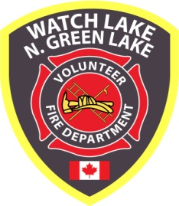 ^{WATCH LAKE – NORTH GREEN LAKE} 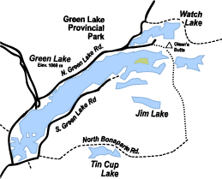
VOLUNTEER FIRE DEPARTMENT

5771 Green Lake North Road
^{70 Mile House, BC, V0K 2K1}

www.wlnglfiredept.org

^{Thank you for your support}
The ominous clouds of smoke have now drifted away and the terrifying tongues of flame that leapt from the horizon linger only as a fading nightmare. As a reminder of what could have been, only a couple of kilometers to the south the black skeletons of the once abundant forest stand in stark contrast to the surrounding blanket of snow. Somehow our homes and properties survived unscathed, but the infamous Elephant Hill Wildfire has had an impact upon the lives of every member of our community.

As everyone knows, our firefighters spent most of the summer conducting a FireSmart assessment of all our properties, providing 24 hour a day security patrols during the evacuation, setting up sprinklers in strategic locations, and assisting in the suppression of the fire when it circled back and threatened the Watch Lake area. The firefighters appreciate the understanding and support they received from the residents during that difficult time. In addition, there were several public meetings held when the fire threat had passed at which community members were able to express their gratitude for all the firefighters had to do to protect the area.

The smoke had barely cleared when several residents made donations to help cover the extraordinary expenses incurred during the summer. Shane Gunn and Darcy Foster from 100 Mile began the commemorative wildfire tee shirt and hoodie promotion that benefitted our department and many others throughout the Cariboo. A very thoughtful lady in Abbotsford purchased a new water pump for us and a similar one for the Southside department. The 100 Mile House Fire Relief Fund and Lions Club collected donations and recently divided the proceeds between our department and three others. But that was just the start . . . .

Now, as the payments of annual fire dues arrive in the mail, many residents have thanked the department with cards, letters and donations. As president of the fire department, I have tried to respond to every donation, but it has now become overwhelming and I can only say thank you to everyone for your support. With your help, we will now be able to pay the summer’s bills.

We were at one time told by the Office of the Fire Commissioner that we would receive no compensation for our time working and expenses caused by the fire. However, thanks to the tireless representation in Victoria on our behalf by MLA Donna Barnett, it appears we will now receive some remuneration for the hours our equipment was in service. If this is the case, we will be able to consider replacing a couple of the older emergency vehicles that are approaching their retirement age.

Our community can be very proud of the fire department we have built over the past 50 years. We have managed to continually budget carefully enough to continually update the equipment and training necessary to meet government standards, however, we are rapidly approaching a crisis in firefighter membership. We need new volunteers! On paper our roster shows good numbers, but we are all getting older and several members will be retiring this year. Membership is open to men and women over 19 years of age, who are willing to spare a couple of hours each week to attend practice and training sessions. Part-time residents are also encouraged to join. Meet some great people, learn new skills, get to wear really attractive bunker gear and, best of all, become a part of the betterment of your community.

For more information and application forms contact:

Fire Chief, Andy Palaniak: phone - 250-456-7460 email - wlnglvfd@gmail.com
or
Deputy Fire Chief, Mark Bulman: phone - 250-456-2151 email - dragnmit@bcinternet.net

Please enjoy the rest of the season - safely. Remember, most of the winter call-outs for the department are a result of misused woodstoves and poorly maintained chimneys.
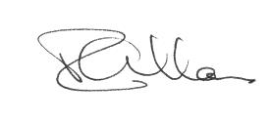
President, WL – N.GL VFD

Late News Notes:

On January 22nd several members of the department attended the Community Wildfire Recovery Meeting held at Interlakes. They returned with the following information that may be of interest and assistance to our community.

- Anyone affected by the past summer’s wildfire who requires recovery assistance may still be eligible for further support and can contact the Canadian Red Cross at 1-800-863-6582 or contact Jon Jackson directly at: jon.jackson@redcross.ca, tel: 250-302-1796 to find out when these programs
start. Workers at the Red Cross can refer applicants to community support or for financial assistance. For example, assistance is available for:

- Firewood or Fuel to heat homes;
- Mental health and well-being – if you are dreaming of fire or smelling smoke when there is none, you may need assistance.
- There is some rebuilding funding available in areas where people lost their homes.
- Other assistance, such as extermination services or mortgage assistance is also available.

- Wildfire Community Preparedness Day – May 5th, 2018 BC Wildfire people are willing to help put on a FireSmart your home course if there is enough interest. Also, if there is enough interest, we could make application to participate in the national event. (see firesmartcanada.ca)

- If there is community interest, we might want to apply/participate in a Job Creation Partnership which is part of Employment Program of BC. As a non-profit Organization we would be eligible. It was suggested that a community might be interested in hiring people to do FireSmarting homes in the community. We have the information, fact sheet and application guide. Apparently, the projects can last up to a year, and the primary focus has to be on the job seeker participants. Giving them recent work experience and additional skills for future employment.

- There was a study on mitigating wildfires back in the early 2000s which gave our area a high danger rating, and it was not acted on. It was suggested that our Department should contact Roger Hollander, the 100 Mile Chief, and see what can be done to get more “home sprinkler” trailers for our area. BC Wildfire said that the whole Province ran out of sprinkler units.

- There is a proposed Disaster Risk and Planning Program. This would help mitigate the risk of
future wildfire.

- Doug Pepper (250-828-4519, doug.pepper@gov.bc.ca) is business risk management specialist and he can talk more about the Agri-Stability Program which helps stabilize farm income by managing the risk of large income declines moving forward (e.g. future wildfires).
Are you interested in purchasing any of the following items?
1. Fire department lock for your gate
For any community members who lock their gates when they are on extended leave, we suggest you purchase a fire department lock to be used in conjunction with your existing lock. This would eliminate the need for emergency services personnel to use bolt-cutters to either break your existing lock or cut the chain to access your property if they need to access your property during an emergency (for example, a fire either located on or threatening your property). It would also save valuable time that would be wasted attempting to break through the locked gate.
How does it work?
The fire department lock is locked to your existing lock as depicted in the photograph below. You use your existing lock to access your property. The key for the fire department lock is only available to members of the fire department and they would only unlock the gate during an emergency if/when they need to access your property. No unauthorized persons would have access to the fire department lock keys, so you don’t have to worry about anyone accessing your property unless it is an emergency.
2. Glossy wildfire maps
We have available a large map that accurately displays the size of each of the wildfires of note for the Cariboo and Thompson-Nicola Regional Districts; the Plateau Complex fire, the Williams Lake/150 Mile fires, the Gustafson Lake wildfire and, most importantly for our region, the Elephant Hill wildfire. This map is in high resolution, brightly coloured in glossy finish to last for many years. It would make an interesting wall-hanging for your cabin, house or shop. The dimensions are 90 cm wide by 60 cm high. We also have a glossy section of that map covering just the Elephant Hill Wildfire that measures 28 cm wide by 40 cm high.
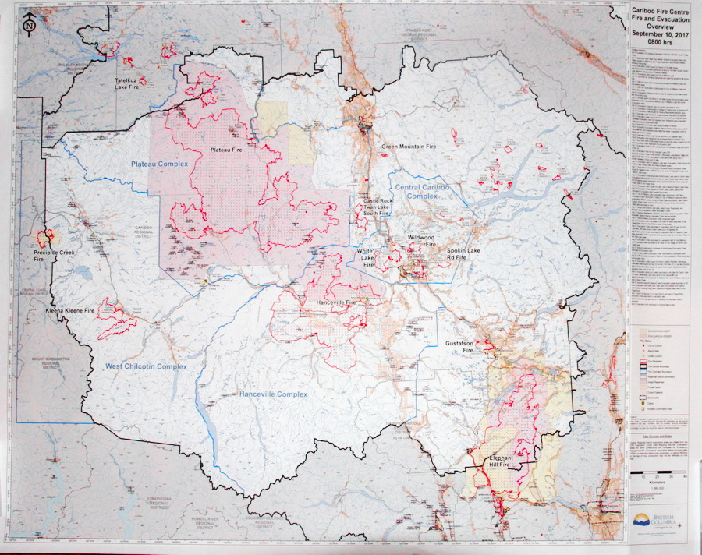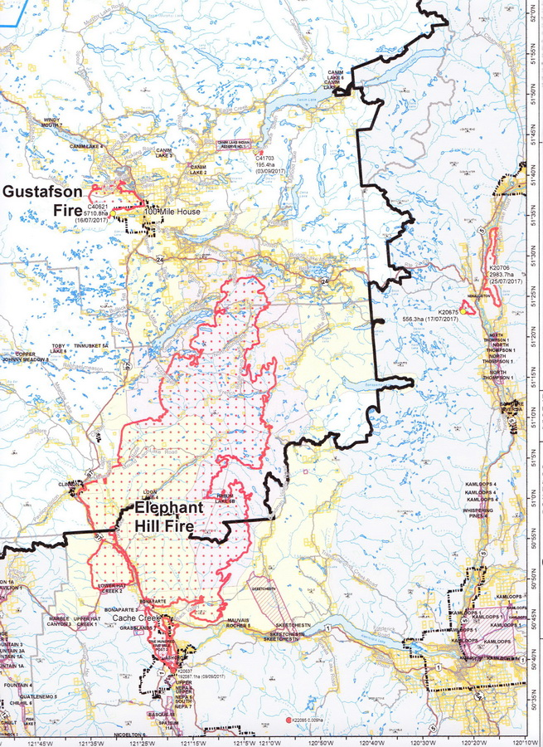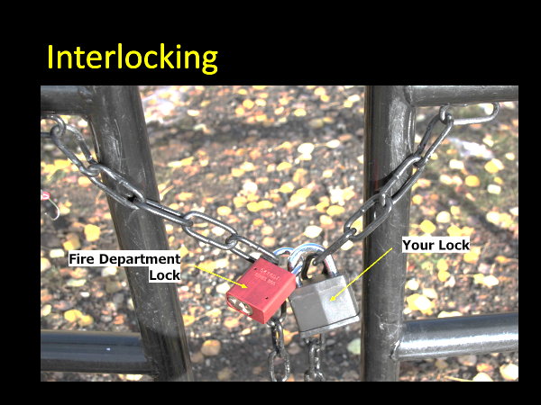
90 cm x 60 cm Cariboo / Chilcotin Wildfire Map 28 cm x 40 cm Elephant Hill Wildfire Map
Please fill in the form on the reverse of this page and mail in with your cheque for payment. Your item(s) will be available for pick up from Hall #2 (5771 Green Lake North Road) on Saturday, May 19th (Victoria Day long weekend) during the annual yard sale/bake sale. If you’re unable to pick up your items at that time, we will make arrangements for pick-up/delivery at a later date.
------ // ------

Please print out your contact information:

Full name (first, last): ____________________________________________________
Mailing address: ________________________________________________________
City, Province: _________________________________________________________
Postal code: ___________________________________________________________
Phone number: _________________________________________________________

Quantity | DESCRIPTION | PRICE (each) | TOTAL
 | Fire department lock | $25.00
 | Glossy Cariboo Chilcotin Wildfire map | $35.00
 | Glossy Elephant Hill Wildfire map | $5.00
 | TOTAL

