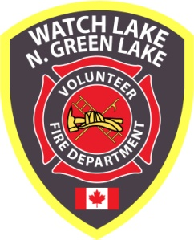 ^{WATCH LAKE – NORTH GREEN LAKE} 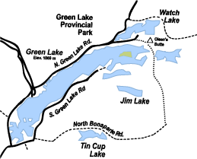
VOLUNTEER FIRE DEPARTMENT

5771 Green Lake North Road
^{70 Mile House, BC, V0K 2K1}
www.wlnglfiredept.org

^{Newsletter - Winter 2012}
Annual General Meeting:
Sunday, February 17, 2013 – 1:00 p.m.
Watch Lake Community Hall

Agenda: President’s Introduction
Secretary’s Report
Treasurer’s Report and Audit
Chief’s Report
Auxiliary Report and Announcements
New Business
Election of Officers

General and Annual Meetings:

We usually have two meetings each year, the annual general meeting and a summer general meeting. Special general meetings may also be called if issues arise that require discussion and voting by the membership. This past summer we did not have a general meeting since there was little that was new to discuss and we would only be wasting members’ recreational time. We did, however, send out an extended, informational newsletter to keep the community up-to-date on department activities. This was our first attempt at sending out an electronic edition to all members who have given us their e-mail addresses and it was generally well-received.

We are required by the Society Act to have an annual general meeting. The specific requirements of this meeting are to provide the membership with the following:

- a financial statement;

- a report of the auditor, if any;

- a report of the directors to the members;

(d) any further information respecting the society as required by its bylaws
or regulations.
Page 2
The annual general meeting also gives us the opportunity to introduce the board of directors who work quietly behind the scene to raise the funds required to keep the department’s wheels turning and to keep the firefighters safely trained and attired. This meeting is one of the few chances we have to showcase the vehicles and the attached firefighting apparatus. The Fire Chief usually gives a review of the equipment condition and gives recommendations for future replacement of aging vehicles. The department’s financial records are available for review at any time during the year and the directors are always available to answer any concerns, however, this is one opportunity for members of the society to publically question the administrative procedures of their department. We always hope for a good turnout at the annual general meetings, but should members be unable to attend, there is always a proxy attached to the newsletter that can be signed and given to a trusted neighbour or friend to vote in their absence.

The Year in Review

To date, this has been a very good year and at times it was like waiting for the other shoe to drop. Your Fire Department is well staffed, well trained and well equipped to face any emergency situation that may arise in our community, but there have been no major fire calls throughout the year. We went through a very dry summer and early fall with no local wildfires. We kept old tender T21 in the fleet until October so that either of our newer tenders could be rented to Forestry if needed. That unit has now been purchased by the recently formed MacLeese Lake VFD.

While things have been quiet for the firefighters, the first responders have had numerous medical aid calls to keep them busy. On one weekend during the summer they responded to three calls in one day.

The Auxiliary also had a good year. The garage and bake sale in May was well attended and members also sold 50/50 tickets at the Little Horse Lodge motorcycle rally in August. Unfortunately, the annual auction and dinner in June was cancelled since conflicting events resulted in poor ticket sales, but on a brighter note, the Firefighters Appreciation Dinner in October was very successful.

As reported in the Summer Newsletter we currently have a roster of 33 members. As a result of an extensive training program last spring 18 of the firefighters are now also trained as first responders and an additional 3 members are first responders only. Our Auxiliary also has about 25 active members who work hard to organize the previously mentioned fund-raising events. Where other departments in our region are having trouble attaining minimum rosters, this is an excellent turnout for a community of our size, and everyone involved with the department should be congratulated for his or her dedication. We would like to encourage any other residents, either full or part-time, to drop by a Tuesday evening practice or call Chief, Andy Palaniak at 250-456-7460 (e-mail: wlnglvfd@gmail.com) to see how you can donate just a few hours of your time to the protection of your community without having to make a long-term commitment. Anyone with carpentry, mechanical or first aid skills would be particularly welcome. The Auxiliary too can always people who can spare a bit of their time to help out at special events. If you can help out here please contact Giselle Poliseno at 250-395-9082 (e-mail: ggpoliseno@gmail.com).

For up-to-date news and event schedules, be sure to check the department’s website at www.wlnglfiredept.org. Director Bob Nathane does a superb job of keeping the site current and informative.
Page 3

Latest Improvements:

Thanks to the hard work and dedication of Vice President Alan Boyd, occasionally assisted by other members of the department, we now have outhouses at both fire halls.

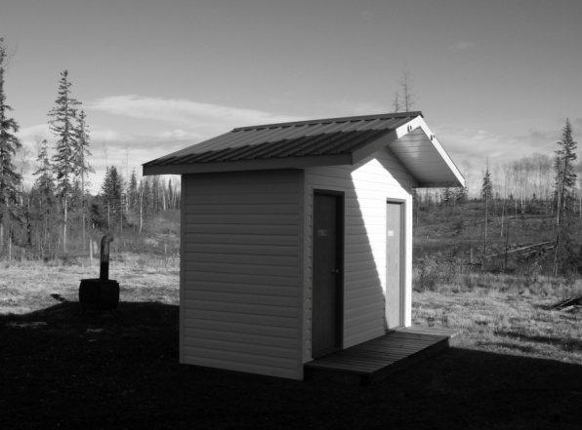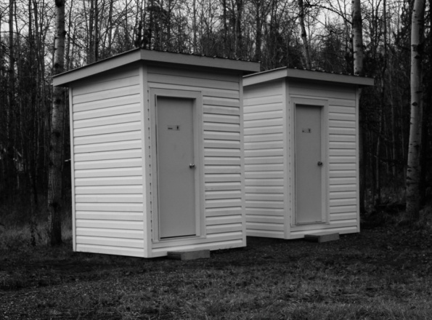

Mr. Boyd and Director Alan Watrich have spent many hours this year keeping our fleet of vehicles in top mechanical shape. Their mechanical knowledge and the welding skill of Vito Burtini have saved us a lot of money and prevented unacceptable down-time.

The fuel shed is also nearing completion and when it is secure we should see a small saving in the storage and purchase of bulk diesel fuel.

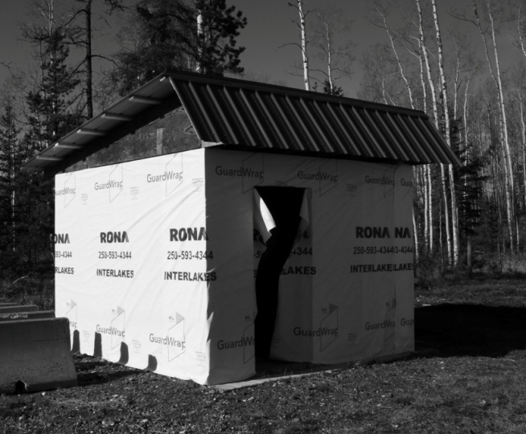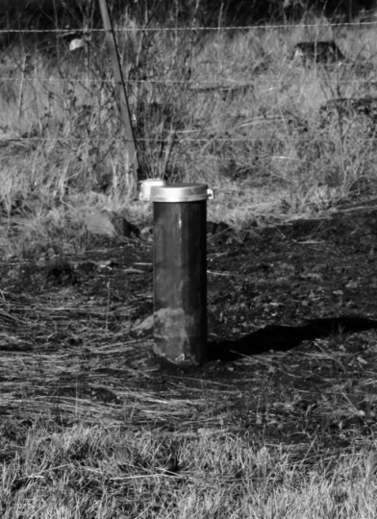

The well at Hall #1 was drilled during the summer, but our water service to the Hall is, as yet, nothing more than the pipe sticking out of the ground. We hope in the coming year to raise enough money to complete the plumbing to the building. The well will continuously feed into the tank to keep the reserve supply at a constant 8500 gallons.

Page 4

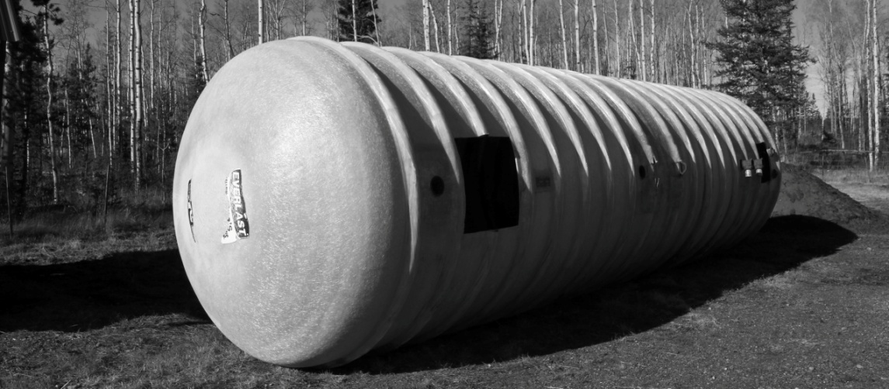

Director Lee Granberg has completed the fiberglass repairs to the water tank and we hope to have the excavation done for its placement in the ground before freeze-up.

Winter is here:

Your fire department is fully prepared and ready to help in case of an emergency, but it is up to you to do everything necessary to prevent fires in your homes. Please heed the Chief’s recommendations on winter fire prevention.

In conclusion, on behalf of the Board of Directors I want to wish you all a safe and peaceful holiday season and every success for the New Year.
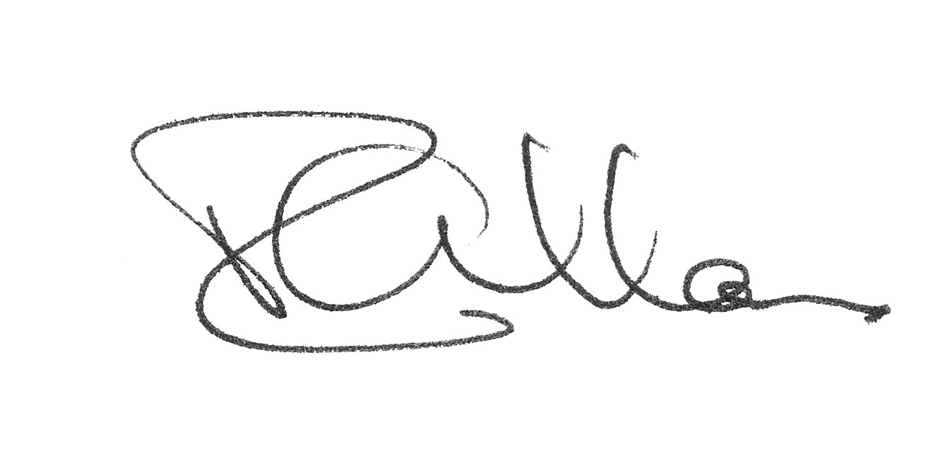
Roy Allan

President WL-N.GL VFD

The Chief’s Corner

Although we have had a quiet year, the firefighters have spent a lot of their weekly training time practising filling the tenders from the lake and with the trailer-pump system they can load 1700 gallons in each truck in just under three minutes. Water can then be delivered to the two pumpers at an incident as fast as road travel allows. The pumpers are reaching retirement age, but they can still dump water on a fire with reasonable efficiency.

The first responders practice regularly and had several opportunities to provide medical aid over the past year. This very important service to our community is an addition to our fire department mandate and it requires considerable time and dedication. Fortunately, several members volunteered to take the extra training required guaranteeing a continuity of service throughout the year

We are pleased to have made it through a very dry summer with no major incidents, but the coming winter months are no less hazardous. Fire statistics from across Canada show that

Page 5

the winter months in this country are the worst for house fires. The following fire safety advice from Fire Prevention Canada will help to reduce the risk of fires in our homes:
- Heating appliances such as space heaters should not have anything combustible close by and need at least one metre (three feet) of space around them. Inspect the electrical cord attached. If it overheats, you have a fire hazard. Keep young children away from them.
- Electrical and heating systems can fail and become fire hazards. Ensure they are regularly checked by a professional, especially prior to the winter season when fireplaces, heaters, appliances and other electrical equipment are in maximum use.
- Smoking while in bed, tired or under the influence of alcohol or medication is the most common cause of fires that kill.
- Most chimney fires occur with wood-burning fireplaces or woodstoves. Ensure chimneys are cleaned and professionally inspected regularly. Burn only small quantities of wood at a time.
- Teach children that fire is not a toy; it is a tool we use to cook food and heat our homes.
- Educate your children about the dangers of fire and make sure they know that all fires, even small ones, can spread very quickly.
- Never use a flammable liquid near a flame or source of spark. Be aware of hidden sources like water heater pilot lights, electric motors or heaters. Never smoke while pouring or using flammable liquids.
- If even a small doubt exists about any appliance/equipment that you use, do not hesitate to contact a qualified technician. It may save your life, and the lives of your loved ones.
Fireplace and Woodstove Safety
A fireplace or woodstove becomes dangerous when accumulated tar or creosote catches fire or from uncontrolled burning or over-fuelling. Other causes of fireplace-related fires are substandard design or installation and lack of safety precautions.
- Open the damper before lighting the fire, and keep it open until the ashes are cool enough to touch.
- Ensure the fire is completely out before going to bed or leaving the house.
- Do not store combustible materials such as paper or wood too close to the fireplace or stove.
- Use a screen in front of the fireplace opening to protect children and to prevent embers from escaping and igniting carpets, etc.
- Never leave children alone near a fireplace.
- Use dry, well-seasoned wood in small amounts.
- Have chimneys cleaned and serviced before the heating season begins.
- Never overload your fireplace or stove.
- Never use charcoal starter fluids, gasoline or any flammable substance to start fires.
- When using artificial logs, burn only one at a time and follow instructions on the wrapping.
- Always place the ashes in a metal container and take them outside the house.
Have a safe winter season.
Andy Palaniak
Acting Fire Chief

Page 6

Financial Statements:

Attached to this newsletter you will find our year-to-date financial statement. Once again we will just make it to the end of our fiscal year. As costs of fuel (both for vehicles and heating), maintenance, electricity and insurance continue to rise, we must budget our funds very carefully. There are just over 83% of the property owners in our community paying their annual dues. These dues barely cover the general operations of the department. The cost for insurance alone is over $2,000 per month. Funding for training, health and safety equipment (including first responder supplies), electronics, vehicle upgrades, construction and renovations can only be covered by grants, donations and fund raising.

When you receive your sticker with your receipt for payment of dues, please place it on your address plaque so we know you are a paid member. Also, when you submit your payment, let us know if you will be away for an extended period and someone from the department will affix your sticker for you.



Guy Aggiss
Director / Treasurer

tear here
 ------------------------------------------------------------------------------------------------------------------

Please return with payment of fire dues if necessary.

My corrected mailing address is:

Name: _______________________________________________________________

Street: ______________________________________________________________

City: ________________________________________________________________

Post Code: _________________________

e-mail address: ________________________________________________________

 Please affix my sticker to address plaque instead of mailing.

Page 7
Watch Lake North Green Lake VFD
Balance Sheet As at 10/28//2012
ASSET
Current Assets
Petty Cash | 300.00
GIC | 3,316.25
Bank Account Gaming | 3,141.15 |  |  | (3141.15 FOR WELL)
Bank Account General | 5,060.42
Total Cash |  | 11,817.82
Accounts Receivable
Total Receivable |  | 0.00
Total Current Assets |  | 11,817.82
Capital Assets
Fire Fighting Equipment | 67,317.59
Net - Equipment |  | 67,317.59
Vehicle | 298,198.56
Net - Vehicle |  | 298,198.56
Building | 335,400.00
Net - Building |  | 335,400.00
Land |  | 22,100.00
Total Capital Assets |  | 723,016.15
TOTAL ASSET |  | 734,833.97
LIABILITY
Current Liabilities
Accounts Payable |  | 0.08
Prepaid Fire Dues | 5,234.00
Total Payables |  | 5,234.00
HST Paid on Purchases | -9,955.20
HST Owing (Refund Approximately 50%) |  | -9,955.20 |  | (APPROX. 50% WILL BE RECOVERED)
Total Current Liabilities |  | -4,721.12
TOTAL LIABILITY |  | -4,721.12
EQUITY
Retained Earnings - Previous Year |  | 783,788.72
Current Earnings |  | -44,233.63
Total Owners Equity |  | 739,555.09
TOTAL EQUITY |  | 739,555.09
LIABILITIES AND EQUITY |  | 734,833.97
Generated On:10/28//2012

Page 8
WATCH LK. N. GREEN LK VFD
Income Statement 01/01/2012 to 10/28/2012
REVENUE
Fire Dues |  | 45,589.79 |  | $5234.00 in Prepaid Fire Dues are included
FF Revenue |  | 0,00
Gov. Grants |  | 20,000.00 |  | THIS IS RESTRICTED FOR WELL AND TANK HALL 1
 |  | __________
NET REVENUE |  | 65,589.79
MISC. REVENUE
GST Refund |  | 4,673.06
Donations & Sales |  | 4,076.23
Refunds |  | 199.76
 |  | ___________
TOTAL OTHER REVENUE |  | 8,949.05
 |  | __________
TOTAL REVENUE |  | 74,538.84
EXPENSE
Accounting & Legal |  | 300.00
Advertising & Promotions |  | 1,265.40
Bank Charges |  | 103.10
Business Fees & Licenses |  | 1,548.00
Courier & Postage |  | 577.92
Freight Expense |  | 554.56
Fire Equipment |  | 15,738.72
Fuel |  | 2,716.49
Insurance |  | 11,098.00
Meals |  | 799.49
Mileage & Travel |  | 2,645.72
Misc. Expense |  | 14,474.17 |  | Weston Water Wells $9778.00
Office Supplies |  | 331.44
Rent |  | 485.00
Repairs & Maintenance |  | 3,527.74
Tools |  | 372.44
Training |  | 3,030.00
UtilitiesTelephone |  | 0.00
Utilities Hall 1 (Gas & Elec.) |  | 1,682.96
Utilities Hall 2 (Gas & Elec.) |  | 1,693.47
Vehicle Exp. FR 11 |  | 1,315.75
Vehicle Exp. Eng. 11 |  | 720.99
Vehicle Exp. Tender 11 |  | 0.00
Vehicle Exp. Tender 12 |  | 313.21
Vehicle Exp. FR 21 |  | 896.00
Vehicle Exp. Eng. 21 |  | 0.00
Vehicle Exp. Tender 21 |  | 0.00
Vehicle Exp. Tender 21 New |  | 42,987.10
Vehicle Insurance |  | 9,509.00
WCB |  | 85.80
TOTAL EXPENSES |  | 118,772.47
NET INCOME |  | -44,233.63
Generated On: 10/28/2010

Page 9

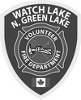 Proxy No: ____
I, (print):___________________________

of local area address: ________________

_________________________________,

as a fire dues paid member of the
Watch Lake – North Green Lake
Volunteer Fire Department (Society)
give my proxy to:
(print)_____________________________

to vote on motions and resolutions raised
at the Annual General Meeting of the
Watch Lake – North Green Lake
Volunteer Fire Dept. (Society)
to be held on Sunday, February 17, 2013*
at the Watch Lake Community Hall.
Signed: ___________________________

*valid only on date shown above

------ // ------

