Some say the world will end in fire, some say in ice.
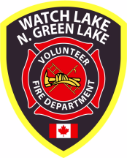 Newsletter – Winter 2011/12

5771 Green Lake North Road, 70 Mile House, BC, V0K 2K1
www.wlnglfiredept.org

Annual General Meeting
Sunday, February 26, 2012 – 1:00 p.m.
Watch Lake Community Hall

Agenda: President’s Introduction
Secretary’s Report
Treasurer’s Report
Chief’s Report
Auxiliary Report

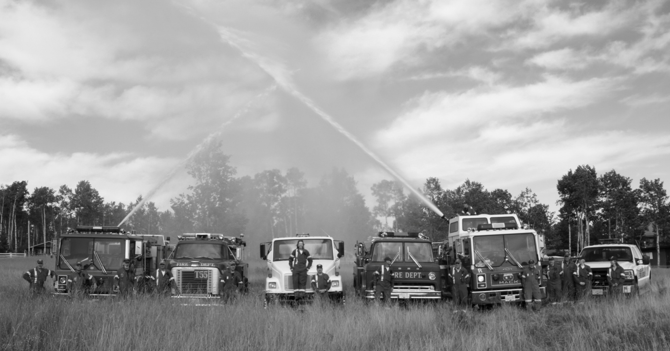

A Good Year

As far as fires are concerned the best news any fire department can have is no news at all. In this regard we have been very fortunate to have made it through the past twelve months with little to report. Up to mid November the grass fires of last spring were the only major incidents of the nine 911 call-outs in our area with which the fire fighters had to contend. There were several trees blown on to power lines that could have caused a problem had our crew not been able to respond promptly. They also provided mutual aid for a couple of fires in the Lone Butte fire district, but we had no major structure or forest fires. The fire hazard created by dead and dying pine trees surrounding our area has been an ongoing concern, but we appear to have now made it through the worst and the majority of the dead trees are now being logged. Throughout the year the first responders have been busy. They had ten medical aid call-outs as of mid November. Training sessions for the fire fighters are held every Monday afternoon with the first responders meeting again every Tuesday evening.

Through very careful budgeting of the funds paid in dues by the community we will again make it through another year's operating expenses debt free. In another article in this newsletter we will discuss insurance, one of our major expenditures. The cost of fuel for both heating the halls and running the vehicles takes another big bite out of the budget. As this expense continues to rise, to keep costs down the trucks are only used as needed for training and emergency purposes. Fortunately, the vehicles require only enough heat to keep them from freezing and the training areas are only heated during the winter months for the weekly training sessions.

Using the one-ton trucks for first responder calls and general transportation has aided considerable in cost cutting. When it snows FR11 will once again be equipped with the snowplough. This proved to be a very valuable addition to the fleet last winter in keeping the access roads open to the lakes for the tenders to obtain water and keeping the parking lots clear so that equipment could be deployed without delay.

If we do have any kind of surplus toward the end of the year, we may be able to combine it with specified funds from the BC Lottery training and safety grant, a small grant from the CRD and a donation from the auxiliary to purchase the final replacement tender.

Our Fifteen Minutes of Fame

Initially, our "no response" policy was suggested to us by Rowena Bastien, the CRD Director of Emergency Services, and Al Richmond, one of the area representatives for the CRD. Mr. Richmond has recreational property in the Felker Lake / Chimney Lake area and their fire department has had this policy for many years. Likewise, the Greeny Lake VFD operates in this manner. All are under the impression that this is only fair for those property owners in their communities who are willing to support their firefighters. Our membership proposed and passed this initiative and we subsequently sent a letter to all property owners who had not paid their current fire dues notifying them of the change in policy. To be sure that this information was getting to all residents we also posted a laminated copy of the same letter at all of the local group boxes.

Within 24 hours most of the letters had been removed. One of these letters appears to have been given to the Free Press and they in turn made headline news out of it. This was picked up by CBC Radio out of Kelowna and they caught up with me by cell phone while I was on a trip to Alberta and requested an interview. Parts of the interview were then picked up and published by The Globe and Mail, the Financial Post and Thompson's Insurance News (an electronic journal that goes out to all insurance brokers).

Then Global TV got into the issue and called several people in the community looking for controversy. As I was still in Alberta, it was arranged for Alan Boyd to present our side of the story with Chief Guy, Deputy Chief Andy Palaniak and Captain / Training Officer Jayne Palaniak in the background. The TV reporter recorded over half an hour of material, but used only the Chief's comments then went looking for opposing views. The rest is history.

Contrary to popular belief, we have not provided any of the insurance companies with a list of the owners of unpaid properties. What they did ask for some time ago and what we have provided is a list of all properties within our fire protection area (without owners' names attached). This is not classified information, it is readily available from the CRD. However, I understand that after receiving the Thompson's Insurance News article a local insurance company has been calling its clients and asking if they have paid their annual fire assessment. Fortunately there are only a few people left in the community who do not support their neighbours in the effort to provide well-trained and well-equipped fire rescue service.

One More Mountain to Climb

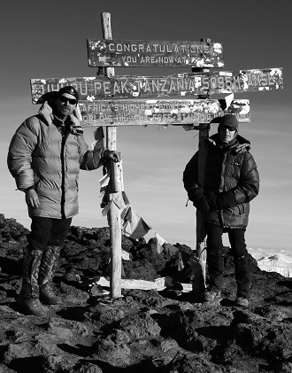

Our congratulations to Deputy Chief, Andy Palaniak, and his wife Captain / Training Officer, Jayne Palaniak on their successful climb of Mount Kilimanjaro. On October 23rd we received word that they had successfully reached the summit. This was a seven day climb with a four day decent in rarefied air that demands a high level of fitness. We expect our fire fighters and first responders to be reasonably fit, but this goes far beyond the call of duty.

In conclusion, on behalf of the Board of Directors I want to wish you all a safe and peaceful holiday season and every success for the new year.

Roy Allan

President

Your Website Talks Back

In the middle of March 2011, the Watch Lake-North Green Lake Volunteer Fire Dept. created its own website - www.wlnglfiredept.org – to keep residents of this area aware of its fire dept.’s activities. By the end of October 2011, there have been over 1,500 visits to the website with a total of nearly 10,000 pages of information reviewed. Some of features of the website include: updated information on the types of equipment the fire department uses to protect our homes and property; photos of the actual firefighters and first responders who do the work; information on how to become a volunteer firefighter; upcoming events and fire-related news, etc. It is through your interest and support that the department has been able to maintain and update this site to keep it current.

Top recent stories that have been of most interest to you include the implementation of the new fire dues policy, the dangers of asbestos exposure, and the recent Firefighters’ Appreciation Dinner, which raised several hundreds of dollars to be used for the purchase of new fire equipment.

Recently, links to the social network Facebook and the photo storage program Flicr have been added to the lower right hand corner of each web page. We are using Facebook to show videos on fire safety and protection, as well as to give you a more global view of actions taken by volunteer firefighters throughout Canada and the United States. If you are a member of Facebook, you can leave a comment or enter your own suggestions about improving the fire department and its website.
Additionally, the department's access to Flicr allows us to post more pictures of our firefighters in action, either at a practice or at an actual fire. Using Flicr, which again has a link from the website, allows us to post hundreds of pictures and show you how the fire dept. operates. If you have your own fire-related pictures that you’d like to post to Flicr, please use the “Contact Us” tab on the website to notify us of your interest.
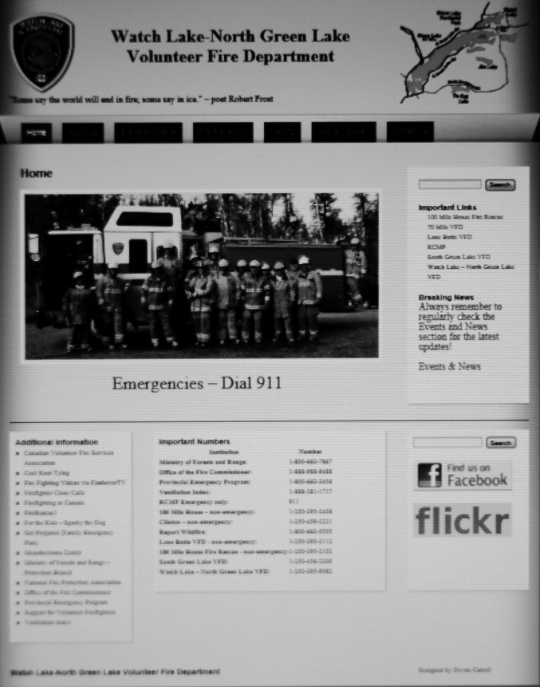

Future enhancements will be expanded coverage of local news that will be of interest as a result of your fire department's actions, an online quarterly newsletter, and the ability to use the website to pay your annual dues. If you have questions, again, please use the “Contact Us” tab on the website to reach us. Also, If you would prefer to receive the biannual newsletter by e-mail, please send us your online address with your dues payment.

We need assistance from the community in making the section in the web site on the history of the Fire Department as accurate and as interesting as possible. If anyone can let us know when various vehicles were acquired or if you can contribute photos and details regarding names, dates and events, please contact Bob Nathane at bob@bnathane.com or write to:

WL - N.GL VFD
5771 Green lake North Road
70 Mile House, BC
V0K 2K1
Bob Nathane
Director / Web Master

Trail Users- Important Request

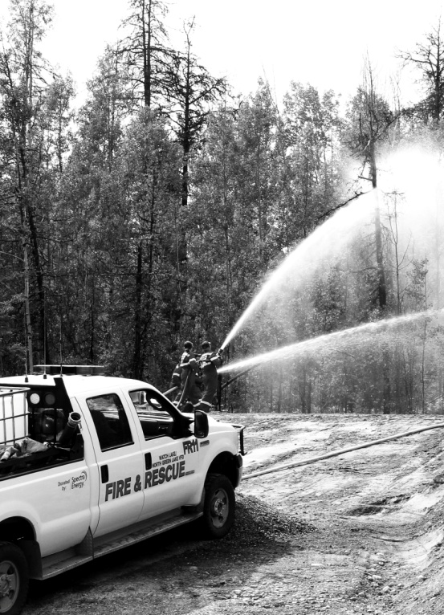

I am writing in the hope that all trail users, snowmobile, quads, and even horse riders will help with the ongoing trail maintenance . I would even go so far as to beg you all to not go out on the trails without a CHAINSAW.

Please do not go around the fallen trees but cut them off the trail, and please cut out enough to make a road that our first attack vehicles can get through in the event of wildfires. Our crews with the one-ton trucks have been able to quickly respond to fires caused by lightning strikes that could have resulted in major fires if the access had been blocked. If we all do some, then perhaps we can then go out and enjoy a ride that does not have a potential heart attack built into it from us retirees trying to do it all. So all you weekenders, please get a chainsaw and help us out. Thank you.

Alan Boyd
Vice President

Legal Review and Update

Review: On October 27th, 2006 this Society received bill for services rendered from the Kamloops Legal Firm of Taylor, Epp & Dolder in the amount of $4,086.68. This bill was for the disputed legal services of lawyer Kenneth Dolder. Initially Mr. Dolder had been paid a $500.00 retainer by the Board of Directors of 2006 and the 4,086.68 was the balance left to pay on the final statement of accounts.

On April 2nd, 2007 the new Board of Directors informed Mr. Dolder in writing that the Society was left with very little funding by the previous 2006 Board of Directors and the immediate payments of the Society's disputed outstanding legal fees was impossible. In the months that followed a number of written and or e-mail communications occurred between Mr. Dolder and the Society but no further payments were ever made and the outstanding balance has been listed on the books of the Society as a liability ever since.

As of October 27th, 2011 this Society can remove that "disputed liability" from its accounting statements because we have passed the five year time period in which Taylor, Epp & Dolder Legal Firm has to file a complaint in Supreme and or Small Debts court to try and recover those disputed legal fees. Obviously Mr. Dolder felt it wasn’t viable for him to try and recover his disputed costs considering the time, court costs and most importantly the issues that were involved which resulted in the outstanding legal billing. The current Board of Directors position of "letting sleeping dogs lie" paid off for the Society in the long run.

Update: As of September 6th, 2011 the Society obtained a written legal opinion in reference to the validity of the Society's position of "Recovery Costs" for firefighting services. This opinion gives the Society a legal point to stand on when and if it would enter into a court case with a non paid member who has refused to pay the Society's recovery costs. As always one must be cautious before filing any court action in the fact that our legal system does not always dispense justice as we may see it, and that the outcome of any legal case that goes to trial is as predictable as the flip of a coin.

Our best defence against future court cases is for every paid member of this Society to promote the payment of yearly fire dues to those property owners who at this time refuse to do so.

Merv Tompkins
Director / Legals

Where does the Money Go?

Members of the board of directors are often questioned about how the money taken in through the annual fire dues is spent. There are certainly no secrets with our finances. A financial summary is distributed to the board members for discussion at their regular meetings. A biannual report is distributed to the membership at the Summer and Annual General Meetings along with an audited report at the AGM. If anyone has further concerns, the books are open for inspection by arranging a mutually convenient time with our treasurer.

By remaining independent of the CRD Emergency Services we continue to enjoy one of the lowest annual rates for fire protection in the Cariboo. Fortunately this is supplemented by the annual training and safety grant from BC Lotteries. However, even with a low annual income this community has, over the past five years, managed to build two new, well-equipped fire halls, replace two of the aging fire engines, add a newer tender and the two one-tons with their attachments.

One unavoidable expenditure is insurance. The nature of our activities requires coverage for just about everything. The department has insurance covering its assets, as well as personal liability coverage for fire fighters, first responders and directors. The assets include two fire halls, trucks and equipment with ongoing updates. Total cost for insuring our trucks alone is $8,022. The two fire halls, along with equipment and liability insurance costs $11,302. WorksafeBC coverage for on-the-job injury costs another $940.50

Insuring the fire halls and trucks is straightforward, while liability insurance requires extra consideration as exposure is always a concern. On this note, in working with our insurance provider of Capri Insurance, Clayton Prince, this policy is widely reviewed each year, looking for potential shortfalls and discussing at length with board members and any interested membership.

Having proper coverage in today's world is an absolute necessity. It is also one of largest yearly expenses. Having adequate insurance coverage gives us the confidence to move forward as a fire department and in supporting our first responders to do the job necessary to protect our community.

Thank you, membership, for your financial support. Without it, none of the above would be possible.

Lee Granberg
Director / Insurance

The Fire Chief’s Corner.

Since the start of the year, one new member has joined the department. The seven members who had started the Basic Fires Fighting Course from the Justice Institute of British Columbia have graduated and will receive a certificate for the course. This course is certified by the Fire Chief’s Association and the JIBC.

Now that the cold weather has started, please ensure that your chimney is clean before starting your daily fire, the department has responded one chimney that was a mutual aid call made by the Lone Butte Fire Department. It was clear that the home owner had not cleaned the chimney for quite some time, the heavy or thick crust of creosote started the fire and spread inside the wall of the living room. The first fire truck on scene was from our department which should prove to some people that we do respond quickly.

In my last report I mentioned that we had problems with taking water from Watch Lake due to weeds and steep hills. A concern citizen mentioned to us that the landing on the right side of Eden road should be good for our trucks. We are re-examining this area and one other close by as well as a pond at Tristan Road. We have verbal approval to make the necessary changes at the pond from the Ministry of Highways, but a formal application will have to be made before we can proceed. We will also require a permit from the CRD.

If you did not do so during Fire Protection Week, please take the time to check the batteries in your smoke detector and make sure it is functioning properly before putting up all your Christmas decorations. A working smoke alarm will beep when smoke is present or when the test button is pressed. Take the time to ensure that the openings on the smoke alarm are not plugged with dust, cobwebs or paint so that the electronic components are able to sense smoke and sound the alarm. I recommend that working smoke alarms be located in every home, on every level (including the basement) and outside each sleeping area. Most manufacturers say that smoke alarms ten years old or older be replaced. Let's all have a safe Christmas season.

When you receive your sticker with your receipt for payment of dues, please place it on your address plaque so we know you are a paid member. Also, when you submit your payment, let us know if you will be away for an extended period and someone from the department will affix your sticker for you.



Guy Poliseno
Fire Chief

Auxiliary News

It is hard to believe that 2012 is just around the corner. This year, the Auxiliary was very busy with successful events including Garage and Bake Sale, Raffle ticket sales and the Dinner and Auction. With the hard work and devotion from these special ladies, I am very happy to announce that in 2011, the Auxiliary accomplished in raising over $10,000 for the Fire Department.

On October 22nd, the Auxiliary had a Firefighters Appreciation Dinner which was held at the Watch Lake Community Hall. Sixty-eight people attended the potluck dinner and everyone had a great time. Being that it was close to Halloween, several decided to dress for the occasion. We are planning to do this again next year and hope to see you there.

The residential address sign project was also very successful with 80 orders. Most of the signs have been delivered, hung up or put away until spring, but I was unable to reach a few of you. Please call me to inform what your wishes are with regards to your sign. Also the 100 Mile Lions Club kindly donated $500 to the fire department for all the hard work. Thank you to all who ordered them. The next address sign project may be in 2013. If you are interested in ordering, please let me know.

We wish to take this opportunity to once again thank everyone in the Watch Lake/North Green Lake community for supporting all our events throughout the year and to wish you all a safe and peaceful holiday season.

For more information about the Auxiliary, contact me at 250-395-9082. New members are always welcome.

Gisele Poliseno
Auxiliary President

tear here
 ------------------------------------------------------------------------------------------------------------------

Please return with payment of fire dues if necessary.

My corrected mailing address is:

Name: _______________________________________________________________

Street: ______________________________________________________________

City: ________________________________________________________________

Post Code: _________________________

e-mail address: ________________________________________________________

 Please affix my sticker to address plaque instead of mailing.

