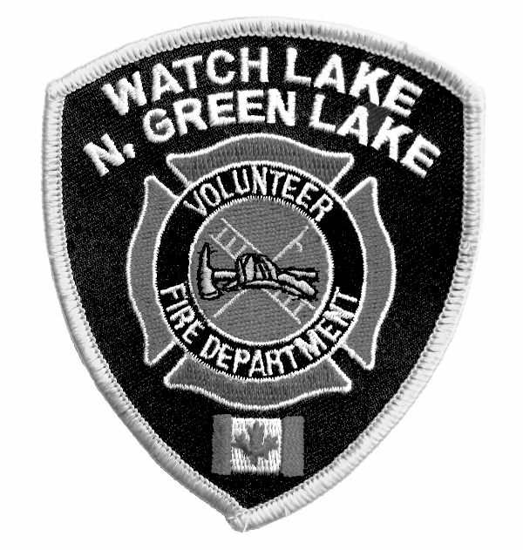WATCH LAKE – NORTH GREEN LAKE VOLUNTEER FIRE DEPARTMENT
R.R. #1, SITE 1, COMP. 4C, 70 MILE HOUSE, B.C. V0K 2K0

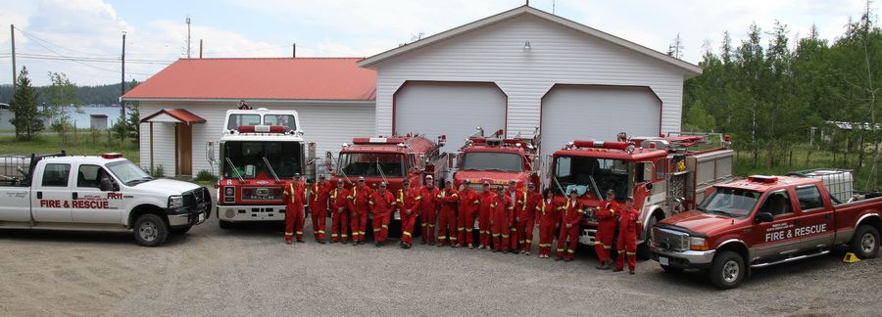

(come early or car-pool since parking will be limited)

Summer is finally here and with the warm weather comes the increased danger of wildfires in our area. The lakes and ponds are at their lowest level for many years and the bug-killed trees are almost explosive. Open burning bans were imposed in April this year and, at the time of writing, open fires are restricted to cooking stoves that use gas propane or briquettes, or to open fires, including campfires, that are one metre in height by one metre in width or smaller. To report wildfires phone 1-800-663-5555 or *5555 on most cellular networks. For local fire or medical emergencies phone 911.

Should we have a fire in our community, our fire department is well prepared to do their best to combat it. It is a credit to the foresight of the founders and to the many volunteers who have over the years helped to build the service we have today and that we can boast of such well equipped and well trained fire fighters and first responders.

As most of you know, the reconstruction of the Shorty Horn Memorial Hall (Hall #1) was substantially complete by the opening event last October. The Sonny Johnson Memorial Hall (Hall #2) is now also completed with the siding finished in May and the re-gravelling and drainage of the parking lot done in June. Without the help of a major capital grant, twenty-five families paying their dues for five years in advance and the hundreds of hours of volunteer labour these projects could never have been attempted. We now have adequate storage for our vehicles and equipment, work areas for maintenance and repair and, perhaps most importantly, year-round, all-weather training facilities. Through funding made possible by the thoughtful donations made to the Shorty Horn Memorial Fund we have be able to install a filling station for the SCBA bottles at Hall #1.

With some careful budgeting and the fortunate influx of unexpected remuneration for fighting fires outside of our area, we have been able to replace the two worn-out emergency vehicles and purchase a used pumper similar to the one donated to us last year by the City of Coquitlam.
The two new-to-us, one-ton pickups will give our first responders quick, reliable transportation to any emergency. These two vehicles have also been loaded with two hundred –fifty gallon water totes and pumps for quick response to spot-fires away from areas readily accessible by the larger trucks. One of the pickups was donated to the department by Spectra Energy. This truck will be fitted with a snow plough during the winter months to give the fire fighters access to properties that might otherwise be snowed-in.

In other news, our legal problems have reached an end! Merv Tomkins did an admirable job in court of representing the membership’s side of the issue, but, in the end, the judge ruled that the case should not proceed. She noted that several mistakes had been made on both sides. Bylaw changes that have already been made and a closer adherence to the intent of the bylaws will insure that this community never again suffers through this kind of a conflict. We sincerely hope that the conclusion of this issue will finally heal the division that has plagued our community for the past four years.

Please have a safe summer. Your fire fighters and first responders are there for your protection, but only you can prevent fires and injuries from happening.

Roy Allan
President, WL-N.GL VFD

The Chiefs Corner

After the lnterface Fire Course I drove around our community and found that if by bad luck we
had an interface fire, it would be difficult to suppress fires in certain areas. Forestry would be in
charge of the overall fire and we would have mutual aid assistance from neighbouring
departments in combating fires around houses at which the owners have done their best to
clear brush, wood piles and other debris that would be fuel for a ground fire. There are,
however, properties in the Moose Point, Moose Place, Pioneer Drive and North Green Lake
Road that need some serious flammable debris removal around the buildings. lt is the
responsibility of each property owner to clear the area surrounding their homes. By clearing
your property you may also be saving your neighbour's home - let's not wait for a fire to occur.

Guy Poliseno, Fire Chief

