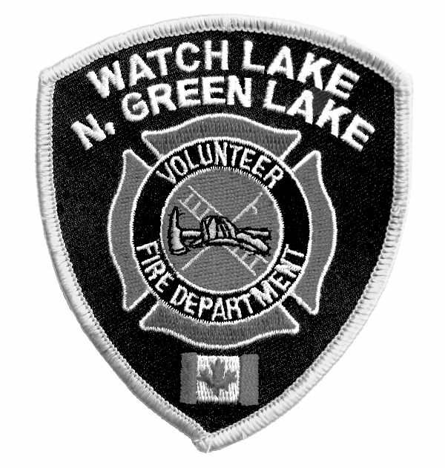WATCH LAKE – NORTH GREEN LAKE VOLUNTEER FIRE DEPARTMENT
R.R. #1, SITE 1, COMP. 4C, 70 MILE HOUSE, B.C. V0K 2K0

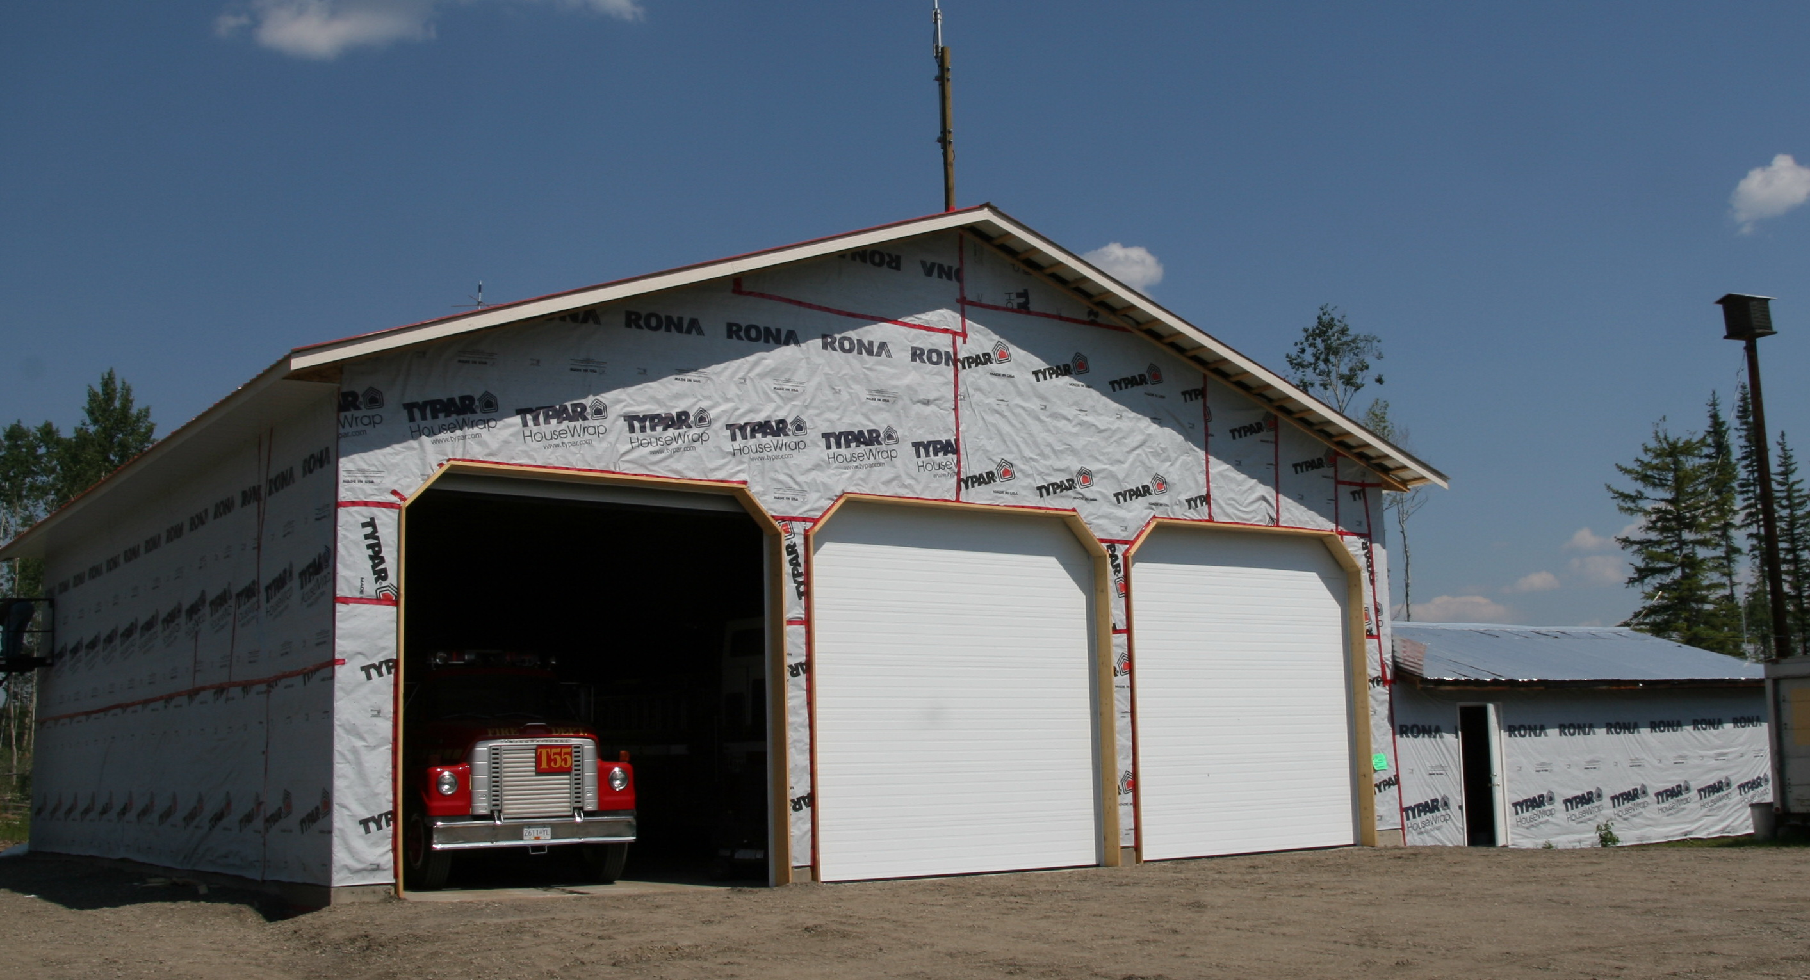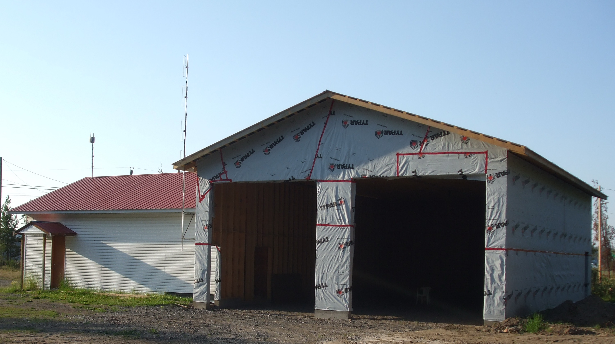
Shorty Horn Hall #1 Sonny Johnson Memorial Hall#2

NEWSLETTER – Summer 2009

Your fire department has been very busy since we sent out the Spring Newsletter. We have had two fires of note in our area, one just over the fence from Hall #1 and the other was a vehicle fire at a campground, but the main action came through our mutual aid agreements with other areas. First of all we attended a grass fire in the Lone Butte protection area on Highway 24 then came the terrible 70 Mile House fire that destroyed several houses, outbuildings and vehicles plus over 1000 hectares of forest. Every fire is a learning experience and unfortunate though it is for those people who lose their homes and property, our fire fighters received a tremendous education in the nature of wildfires and in the capabilities of their own equipment. Our people also received the recognition of their peers from other areas that they have the ability to work side by side with them in any emergency.

Our first responders have had their share of action as well. Most recently they attended a possible heart attack in the middle of the night, a motorcycle accident where the rider was hit by a deer and suffered a severely broken leg and a near-drowning at Emerald Bay.

As you can see in the photographs above, the reconstruction of both fire halls is progressing well. This would not be happening without the tremendous community support we have received. We are fortunate to have so many people in the area with building and technical skills who have given so much of their time to make this dream a reality. If you haven’t done so already, please stop by either hall over the summer and give the volunteers some encouragement. In fact, why not bring a hammer – more help is always needed.

Our grand opening celebration day will be on Saturday, October 10 with dedication ceremonies at both halls and a dinner-dance in the evening. Please mark that date on your calendar and try to attend. (Time and location details will be announced in the local newspapers.)

The Summer General Meeting will be held on Saturday, September 5 at 1:00 p.m. at the Watch Lake Community Hall.

We hope you are having a safe summer. With our forests so tinder dry please be careful with any kind of fire. As we have seen in other areas, the smallest of fires can spread very quickly, with devastating effects.

Yours truly,

Roy Allan
President, WL-N.GL VFD

