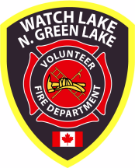 Newsletter – Spring 2011

Summer General Meeting
Sunday July 3, 2011 – 1:00 p.m.
Watch Lake Community Hall

Agenda: President’s Introduction
Secretary’s Report
Treasurer’s Report
Chief’s Report
Modification to Bylaws

Winter seemed reluctant to leave this year. At the time of writing, the ground is still frozen and there are still a few patches of snow in shady areas. However, the forest is tinder-dry and the grasslands are extremely flammable. This will only get worse as summer progresses and, of equal concern, the water levels in the area’s lakes and ponds have risen only slightly. As of the Easter weekend our fire fighters had been called out to fight two grass fires that started as small spring clean-up burns and rapidly got out of hand. On May 2nd fire restrictions were put in place so please check the current regulations before having a fire of any kind.

Fortunately, with both fires it was not too windy and the crew was able to stop the fires before they spread to neighbouring property or too far into the forest. Once again the supply of water taxed the old tenders to the maximum of their ability. The second fire was on Little Green Lake Road and had spread to just about an acre by the time the 911 call was made. The standard operating procedure with a fire of that size is to call for mutual aid so the Lone Butte VFD sent a tender and two of their members to help out. At the time of these fires our newest addition to the fleet was one day away from being ready for work.

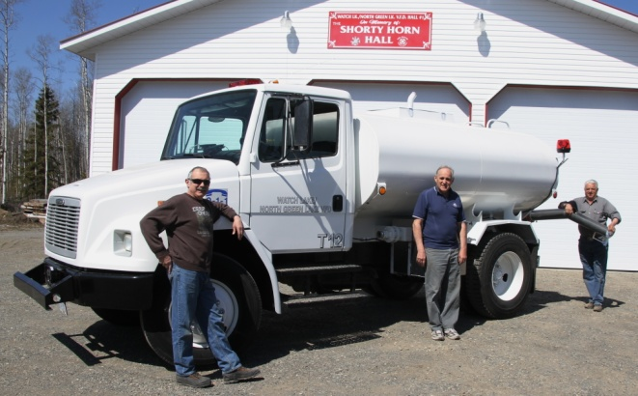

This new (to us) tender is a 2006 Freightliner with a 1700 gallon water tank. It was originally used by a hydro-seeding crew in Arizona and has seen very light service with no salt. The additional capacity and greater power will assist the fire fighters in getting water to a fire scene with a far better turn-around time than with the older tenders. Chief Guy, Vito Burtini and Brian Thatcher all worked

diligently for over a week to get the truck prepared for service. It is now outfitted with two-way radio, siren, emergency lights, tool locker and most importantly a three-way dump valve on the rear. With this valve in place the tender can meet with the one-ton, trailer and pump combination at the lakeshore and be filled in less than four minutes. When it arrives at the fire it can be emptied into the portable pond in less than three minutes. Old tender 11 will also be fitted with a one-way dump valve so that it can deliver water in the same manner.

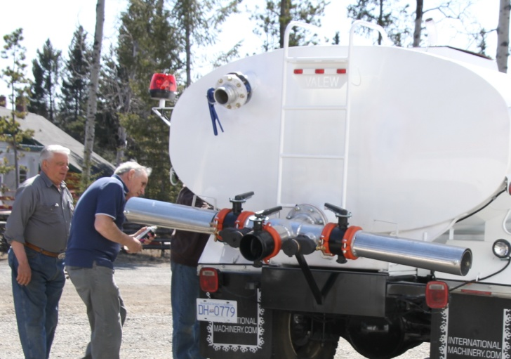

We are reasonably well equipped for any fire and should soon be able to qualify for the Fire Underwriters’ 3B rating that will result in reduced annual insurance costs for us all. Without the financial assistance of the partial proceeds from a BC Lotteries Gaming Grant, a very generous donation from our Auxiliary and a $5000 grant from the Cariboo Regional District we would not have been able to make this purchase. It is very important that we continue to find outside sources to help us continue to upgrade the vehicles since it is only through some very careful budgeting that we are able to cover all of our operating expenses with the funds raised by the payment of annual fire dues.

Your Fire Fighters and First Responders are now supported by the dues paid by over 80% of the property owners in this area. Unfortunately, there are still a few people who do not support the volunteer service of their neighbours and who would rather risk paying the $1000 per hour service fee if a fire was to originate on their property. We have so far avoided going to Small Debts Court to recover the service fees owing on a couple of 911 call-outs to unpaid residences, but these are still pending.

Several of the Board members recently met with officials from the CRD to discuss the collection of dues in conjunction with property taxes. This is done quite successfully in the Thompson – Nicola Regional District, but the CRD is reluctant to provide that service. They did, however, question the legality and insurance coverage of responding to fires on non-member properties. There is a good possibility that our fire fighters would not have WorkSafeBC compensation coverage if they were to enter properties upon which the dues have not been paid. Rowena Bastien the CRD’s Manager of Protective Services suggested we look at how other local independent departments such as ours respond (or don’t respond) to emergency calls from non-members.

A survey of these other departments revealed that the Horsefly VFD, for example, takes a chance that no harm will befall their fire fighters and responds to all emergencies. They then send an invoice to property owner’s insurance company and, when necessary, they have successfully taken the insurance company to small debts court. The Greeny Lake VFD sends a letter to all owners of non-paid properties informing them that the department will not respond to calls from that address. They will, however, protect surrounding paid property.

The Chimney Lake & Felker Lake Landholder’s Association includes the administration of their community’s volunteer fire department in their constitution and bylaws. In these bylaws they state that the department is “...limited to servicing only those members in good standing of the Association.” Non-members are the owners of property upon which the dues have not been paid. At a predetermined date in the Association’s fiscal year a letter is sent to all non-members. The title of this letter states: “This letter is formal notification that you do not have fire protection services.”
Within this letter non-members are informed:

Our constitution provides no authority to enter onto non-members property. If you are not home we will not enter.
If we have surplus resources, and are verbally requested on scene or via the 911 dispatch coming from your residence, [we will] provide fire protection services to the best of our ability at a cost of $1000 per hour measured from the time of the alarm to the time the apparatus is cleaned and returned to service.

They further point out to non-members that:

As a courtesy, we remind you that your home owners insurance may not cover losses due to a fire if your membership is not paid. The common wording in home owner policies is, “is your home within 8km of a responding fire hall?” The key word is “responding”. If you are not a member we are under no obligation to respond. Our membership list is proposed for distribution to the local insurance companies.

At the July meeting the Board will ask the membership for their direction in adopting a no-response operating procedure similar to that of the Chimney and Felker Lakes Landholder’s Association as outlined above. This will consist of bylaw changes, a letter to property owners who have not paid their fire dues and a letter of consent form that will be carried in command vehicles to be signed by the non-member at the emergency scene. Please come to the meeting prepared to offer any suggestions in this matter. If you cannot attend, please relay any concerns you may have to a Board member or contact the Board by mail.

Sadly there are still a few property owners in our area also who refuse to support the services provided by this department and they force us to continue with the fees for service as described in the society’s Bylaws and duly recorded with the Registrar of Companies in Victoria. Annual fire fees were due on January 1st of 2011 and members of the Society for the past year were not deemed delinquent until March 1st of 2011. After March 1st we have in the past said that a list of all unpaid properties will be submitted to all local insurance underwriters. One very brave Board member is personally contacting the owners of all unpaid properties. He is finding that there are still a few people who do not understand that fire services are not covered by their taxes and he has found a few properties that have never been on our mailing list. When he has finished canvassing our fire area the final list of unpaid properties will be distributed to local brokers and insurance companies.

As we mentioned in the last newsletter our fire fighters and first responders deserve far more than just the occasional pat on the back and we encourage all residents to go to the web site givefirefighterscredit.ca and support the Canadian Association of Fire Chiefs’ proposal to introduce a $3,000 non-refundable tax credit for volunteer firefighters who perform more than 200 hours of service per year. A tax credit 15% on a maximum of $3000 with restrictions and a means test actually appeared in the last federal budget but was not voted upon. There is now a danger that it may never appear again if we do not continue our support and show our concern. Please request that your Member of Parliament pursue this issue in Ottawa.

We must once again thank the members of the Auxiliary who spend so many hours in preparing for the special fund raising events that have become so much a part of community unity. By the time you get this newsletter the annual bake and garage sale will be over, but judging by the sale items already collected and the baking that is in progress the event will no doubt be another great success. At last count the Auxiliary had 127 pies ready for sale.


Please plan to attend the Summer General Meeting in July and bring forward any questions and concerns you may that that will contribute to the continued success of your Fire Department.

In closing I wish to thank all members of our community for the continued support of your fire department and on behalf of the Board of Directors we hope you have a safe and enjoyable summer, holiday season.

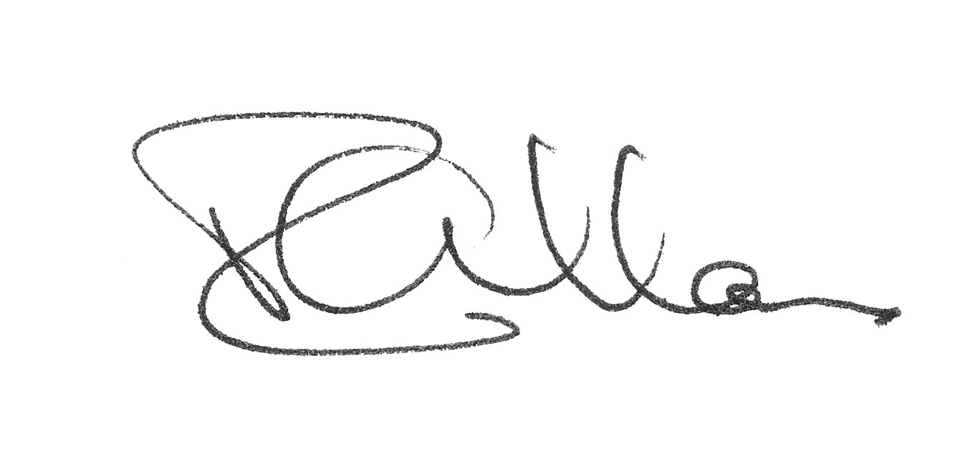
Roy Allan, President
WL – N.GL VFD

Please visit the web site at www.wlnglfiredept.org

The Fire Chief’s Corner.

Since the start of the year, two members left the Fire Department and two new members have joined the department. In April seven members started the Basic Firefighting Course and seven more will start upon completion of the first group. This will bring the department to 90% of the members with BFFC completed.

This year the Fire Department has grown in assets by obtaining one new tender with a water capacity of 1,700 gallons. This brings our total water carrying capacity up to 5,600 gallons counting all fire apparatus which now includes 3 Tenders, 2 Engines and 2 quick response vehicles.

We recently added a one-way dump valve to old tender 11 so that it can be quickly emptied into the portable pond in the same way we can with the three-way valve on the new tender, T12.


The ban on burning has been in effect since May 2nd due to the high number of fires - 11 in total in the South Cariboo, all started by people.

We live between two beautiful lakes, but, in event of a fire, Green Lake is the only lake that has public access for firefighting. We took a drive last week around both lakes. Around Green Lake we have identified seven good access roads with a gentle slope to the water with no weeds by the edges, plus the Provincial parks accesses.

In contrast Watch Lake has also seven public accesses but all were made with the fishermen in mind and not the fire department. The bottom of Watch Lake is muddy and the edge is full of weeds; not good for pumps but great for fishing. The two largest accesses, one on Eden road and the other by Ace High, are too steep for our tenders and the water’s edge is covered with weeds. The remaining public accesses on Moose Point Dr. are too steep and are also covered with weeds. Watch Lake would only be good for helicopter pick up and water bombers.

Guy Poliseno
Fire Chief

Auxiliary News

The Auxiliary would like to thank everyone who attended our 15th Annual Bake and Garage Sale held on May 21st. We all had a great time and the sale was very successful.

The members are still busy selling raffle tickets to help purchase new equipment for the Fire Department. The prizes will be drawn on June 18th. The tickets can be purchased at the Cariboo Mall or Save-On-Foods in 100 Mile House or from a member.

Our next big event will be the 3rd Annual Dinner and Auction. This will take place on Saturday, June 11th at the 70 Mile Community Hall. Doors open at 4:30 p.m. with dinner at 5:30 and the auction commencing at 7. Come and support the fire department. Invite your friends for an evening of excellent food and a fun time. The meal will be served by BJ’s Catering and our auctioneer, Donna Nivison, will keep the bidding going with fun and merriment. Tickets are $20.00.

If you would like to purchase raffle tickets, dinner/auction tickets or would like more information with regards to the Auxiliary, please contact me at 250-395-9082.

Gisele Poliseno
President

