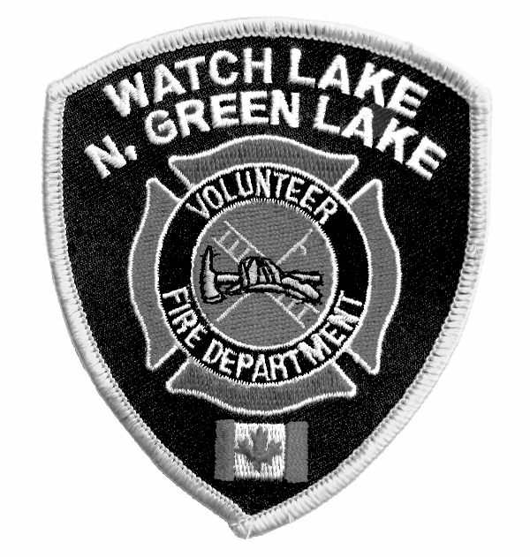WATCH LAKE – NORTH GREEN LAKE VOLUNTEER FIRE DEPARTMENT
R.R. #1, SITE 1, COMP. 4C, 70 MILE HOUSE, B.C. V0K 2K0

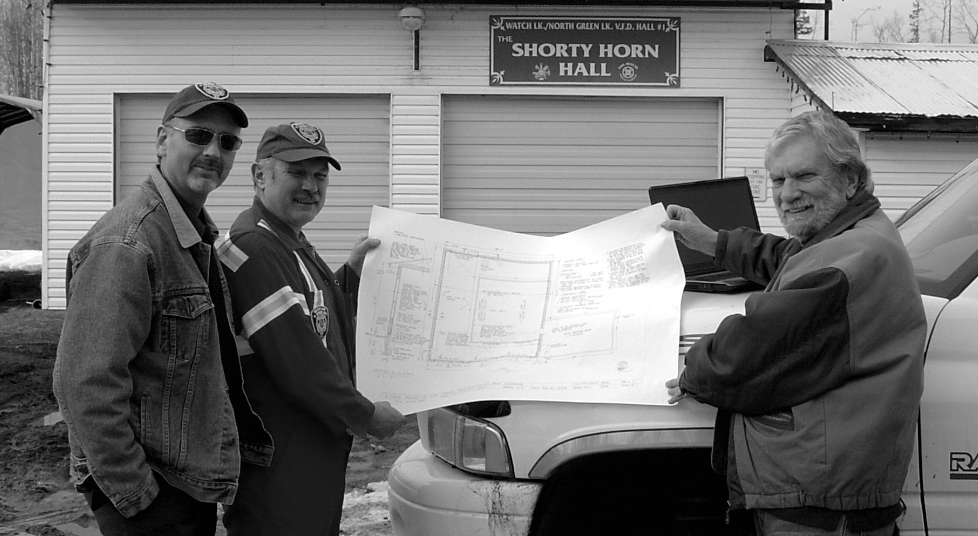
Assistant Chief, Greg Moro; Chief, Guy Poliseno and Board President, Roy Allan review plans for the expansion to Hall #1

NEWSLETTER – Spring 2009

Sad news. As we are putting this newsletter together, we have just received news of the passing of Shorty Horn, the owner of Watch Lake Lodge and our first Fire Chief. Shorty will be sadly missed by everyone in the community. He seems to have been here forever and we all have our favorite stories of his many contributions. We wish to offer our condolences to Shorty’s family – our thoughts are with you.

In other news, we are pleased to announce that we have received the Capital Grant of $56,970 in matching funds to begin the reconstruction of the fire halls. The plans for both Halls 1 and 2 will provide room for our new truck and for larger replacement trucks as we are able to find them. There will also be expanded assembly and meeting areas in both Halls to allow for year-round training sessions. This will be the biggest community project this department has undertaken since the building of Hall #2 in 1991 and will certainly be the biggest for decades to come.

Now the fun begins! We have a list of volunteers who have signed-up to offer their enthusiasm and expertise in the project; the challenge will be to coordinate this energy throughout the project. Our Chief, Guy Poliseno, and Vice President, Alan Boyd, have offered to donate even more of their time to act as Construction Coordinators. They will be contacting volunteers as the need for labour and assistance arises. For our out-of-town members, if you are able to help out while you are here, please contact Guy at 250-395-9082 or Alan at 250-456-7651 and let them know when you will be available to contribute a few hours. This is a community project and we need the involvement of the whole community.

So far 2009 has been quiet for our fire fighters and first responders, but throughout 2008 they responded to 28 calls. There were several medical aid calls for the first responders and the fire fighters were called-out to emergencies involving motor vehicle accidents, hazmat, wildfires and two major structure fires. The many hours of training spent by the volunteers has resulted in a truly professional department.

At the Annual General Meeting held on February 21st, the following people were elected to the Board by the members present:

Alan Watrich Merv Tompkins Robin Rusaw Karen Parlee Guy Aggiss
Joanne Macaluso Lynda Krupp Lee Granberg Alan Boyd Roy Allan

The Directors met on March 6th and re-elected the 2008 executive to remain in those positions for one more year.

Auxiliary News:

The Auxiliary Society Annual General Meeting will be held on Tuesday April 7, 2009 at the Watch Lake Community Hall: 9:30 a.m. Coffee, 10:00 a.m. meeting. Please contact Auxiliary President Jonni Guenther for further information at 250-456-7330.
AGM Agenda:
Planning of 2009 activities
- Garage Sale May 16, 2009 (start cleaning out your closets and basements)
- Dinner & Auction June 20, 2009
- Fire Fighter’s Ball – October 10, 2009
- Meet & Greet picnic
- Important monetary decisions
- Election of officers
New members (men and women) very welcome for the very low $2.00 annual membership fee.

Many members picked up their sticker at the AGM or have obtained one from a Board Member. If you have paid your dues for 2009 the sticker will be attached to this newsletter. Please place it on your address number plaque at your driveway entrance. | 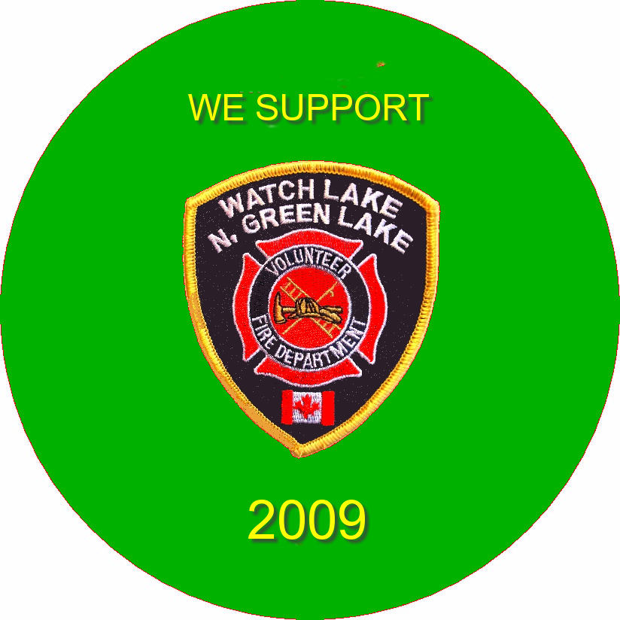

As I pointed out in the December Newsletter, the 2008 fiscal year saw the best payment of fire dues by property owners in the history of the Department. Payments for 2009 have been excellent to date, but I must point out that in keeping with the procedures in other communities we will be charging a service fee for fire response or emergency service to unpaid properties. There has been an unwritten fee for service for many years, but to make this enforceable the following service fee structure was voted into our bylaws at the Summer General Meeting and came into effect as of January 1, 2009.

This bylaw, Article #21, states:

Services for property owners who have not paid their current fire dues:
a. There shall be a service fee of $1000.00 per hour for 911 call-outs, (minimum of 2 hours.).
b. There shall be a service fee of $500.00 for 911 First Responder call-outs.
c. Members of the Society of the present year will not be deemed delinquent until March1st of the following year. (e.g. 2008 members are delinquent as of Mach1, 2009)
d. The board will have the right to either use the Small Debts Court and / or a Collection Agency to recover service fee stated in (a.) and (b.) above.

We expect to start construction on both halls in May as soon as the ground thaws. Even if you don’t have time to help out, please drop by to see what’s happening and offer a few words of encouragement.

Yours truly,
Roy Allan
President, WL-N.GL VFD

The Fire Chief’s Corner.

Since the start of the year, 9 members of the Fire Department have graduated from the Basic Fire Fighting Certification Program given by the Fire & Safety Division of the Justice Institute of British Columbia and were presented with their certificate at the AGM.

In September of 2008 Merv Tomkins through dedication and perseverance submitted and was successful in obtaining for us a $25,000.00 Gaming grant. This grant is for Safety Equipment and Training for the Fire Department. So far we have purchased two Ponds which are used to store water from the Water Tenders for use by the Pumpers at a fire scene.

We also have purchased a Thermal Image Camera (TIC) which is designed to assist firefighters to see in low visibility conditions of smoke and darkness. This camera could also be used for search and rescue, initial scene assessment, locating the base of the fire, determining entry, ventilation points and more. Due to the high cost of these items, it would have been impossible to purchase them without this grant. Again, thanks Merv for all your hard work.

In the past few months, a contractor for BC Hydro has been cutting the dead Pine that represented a possible problem for the power lines along the roads and on private property. Just a reminder to all who are burning the dead pine, whether on your property or along the road, you must obey the venting regulations and please don’t burn too close to live trees. For daily venting index phone 1-888-281-2992 and to register with Forestry if you have burning piles of over 2 cubic meters call 1-888-97-1717.

Guy Poliseno
Fire Chief

------ // ------

