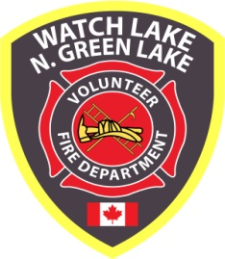 ^{WATCH LAKE – NORTH GREEN LAKE} 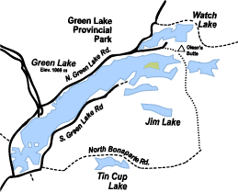
VOLUNTEER FIRE DEPARTMENT
Annual General Meeting
1:00 p.m., Saturday, October 21st,
Watch Lake Community Hall
5771 Green Lake North Road
^{70 Mile House, BC, V0K 2K1}

www.wlnglfiredept.org

Newsletter – Fall / Winter 2017
A Summer of Wildfire

As the events of this past summer unfolded we were kept informed of the progress of the Elephant Hill Wildfire on a daily basis through the postings on our web site (a record of almost 4000 hits in August) and on our Facebook page. The South Green Lake Community Group Facebook page carried ongoing news, comment and updates. I am assembling a selection of photos of what we all did during this past summer, both here at the lake and during our forced evacuation elsewhere.
Please submit any photos of your summer during the fire that you would like to share in the Elephant Hill Fire Gallery to summerfire17@yahoo.com
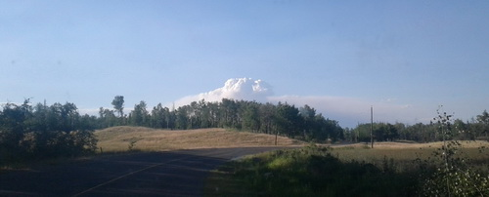
Who would have thought when the first ominous clouds of smoke rose from the Gustafson Fire just outside of 100 Mile House on July 6th that a second fire starting as far away as Ashcroft would wreak such massive devastation from there to Sheridan Lake. Many of our friends and neighbours in Ashcroft, Loon Lake and Pressy Lake would lose their homes, ranches and rangeland would be devastated and thousands of hectares of forest would be totally destroyed. Both sides of Green Lake and Watch Lake were under evacuation orders for extended periods of time with many of our fire fighters from both the North and Southside departments staying behind to assist the RCMP, the Military and the Structural Fire Specialists in patrolling the area and in protecting our properties.

Page 2
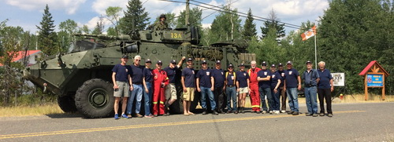
The Elephant Hill Wildfire threatened our community, but passed by just to the east. Just when we thought the danger had passed, a north wind blew the flames back toward Watch Lake and came close to attacking us from that end.

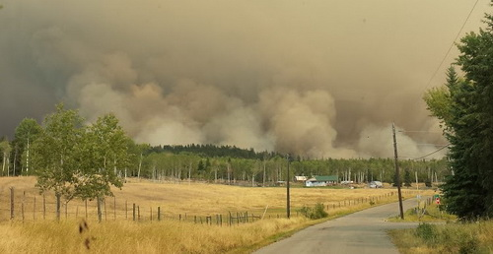
The fire finally stalled at Sheridan Lake, causing an evacuation of the area and a stretch of Highway 24.

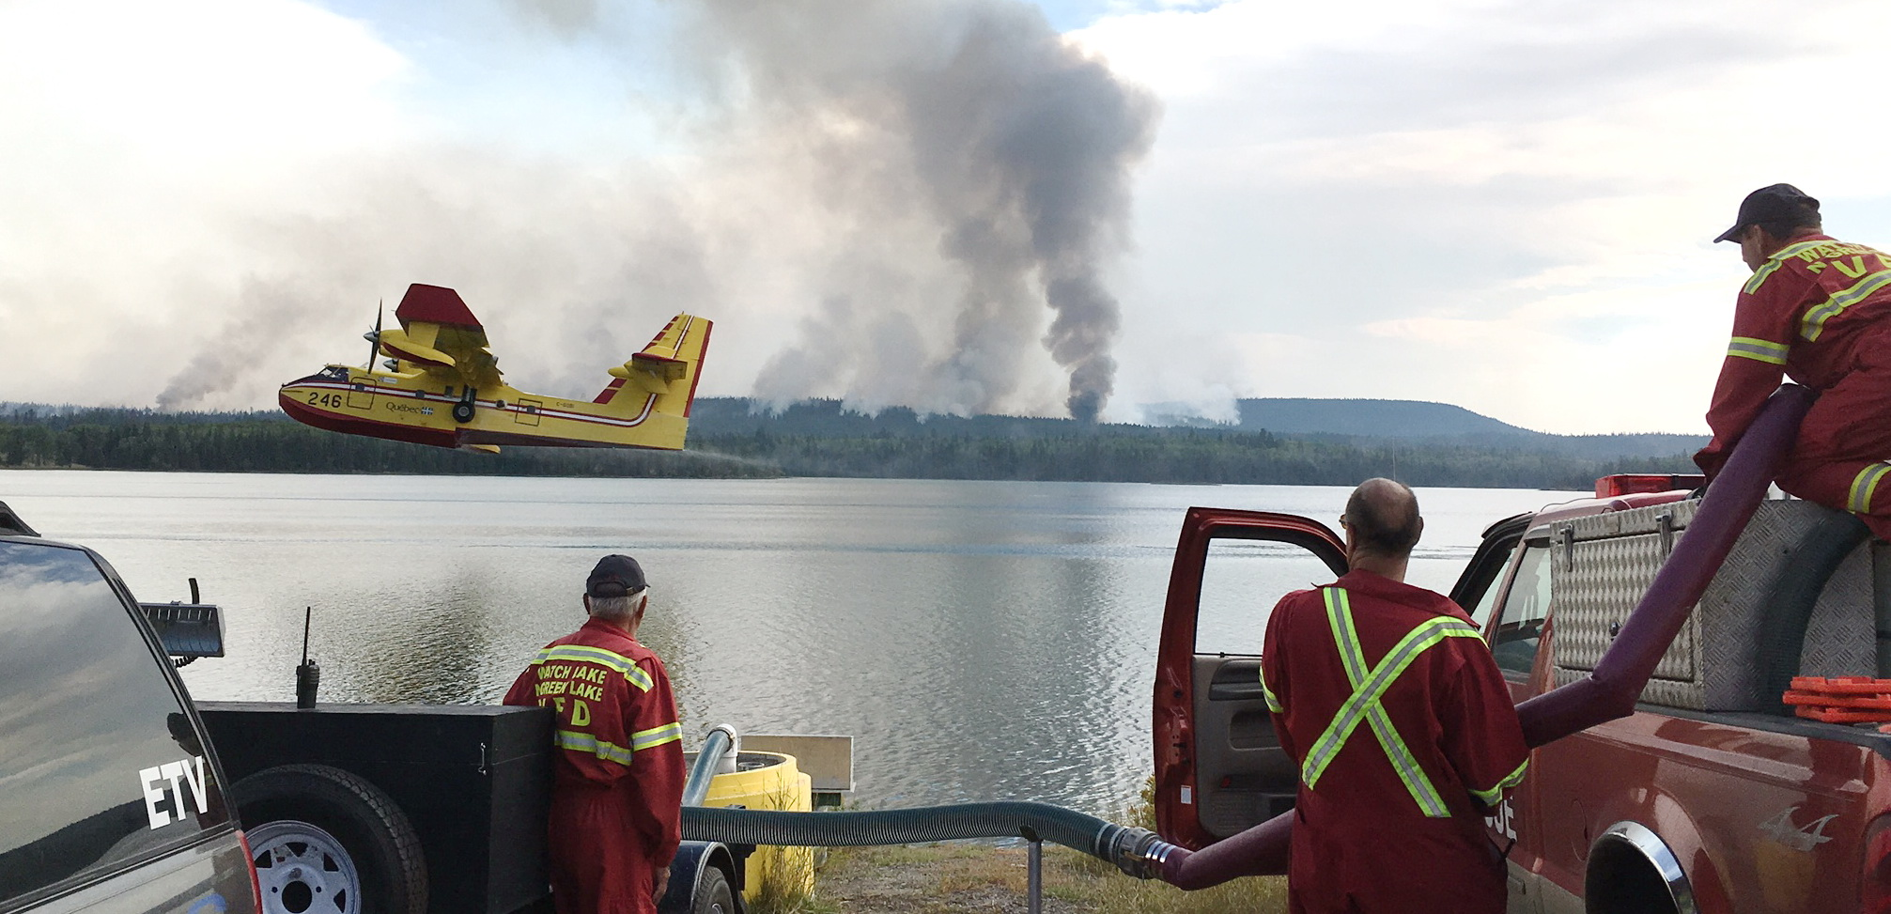.

Page 3

For most of us who live in and visit the Watch Lake – North Green Lake community it has been a summer of stress, inconvenience and the loss of a season’s lakeside activity. We can be thankful, however, that no lives were lost and no private property was damaged. Unfortunately, it will take a lifetime for the surrounding forests to recover.

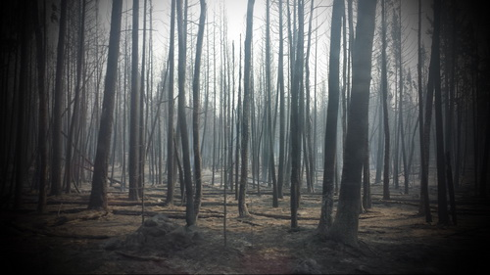

Our Community Protected

The Elephant Hill Wildfire posed a serious threat to our community and, while we were all evacuated for most of the summer, our firefighters remained on duty to protect our properties. They worked with the RCMP and Military 24 hours a day to ensure that everyone had left the community safely. When the area was clear of residents and the fire had advanced closer, under the direction of the Office of the Fire Commissioner, our crew conducted a FireSmart survey of all 525 properties. This entailed removing all flammable materials (cushions, couches and propane cylinders) from decks and moving woodpiles away from the sides of structures. At the height of the fire to the south our side of the lake had ash and partially burned pine needles and twigs raining down. The 20 firefighters on duty throughout July and August divided into shifts to patrol the area day and night to provide security for all of our properties and to watch for spot fires caused by the falling embers. Upon our return many of us were shocked to find so much half-burned material on our lawns and roofs.

Just when it looked as though the danger had passed, the fire turned around and started to move back toward Watch Lake. Our members worked with the Forestry fire suppression crew to stop the fire at Olsen’s Flat and Little Green Lake. Fortunately, with the aid of the ground crew and thousands of gallons of water dropped by aircraft the fire did not proceed further into our area and went on to finally die down at Sheridan Lake.

Since we are a volunteer community fire department and since we did not leave our fire protection district, we receive no compensation from any government agency for our participation in the

Page 4

suppression of this fire with the exception of remuneration for the two days fighting the fire at Little Green Lake. Our extraordinary expenses have been far beyond our normal operating budget. However, we have had some very generous donations from three families with property in the area, as well as $2500 from the tee-shirt sales in 100 Mile House, $725 from a group of friends who donated the winnings of their annual fishing derby, and several property owners have paid their fire dues for the first time. The department is truly thankful for this very thoughtful support.

As we review the department’s activities over the past three months there can be no question that the fire dues of $170 per property per year is a small price to pay for the quality of service and total dedication your volunteer firefighters provide.

Annual General Meeting

The annual general meeting for 2016 was delayed until July 15th of this year so that more summer residents could attend. Well, needless to say, that never happened. We have to have this meeting by the end of this year and have now set October 21st 2017 as the most convenient date before the snow flies. Please try to attend. It won’t be a long meeting, but we will review some of the highlights of last year. If you have any comments, concerns or complaints this is the time to air them. If you can’t attend , please fill out the attached proxy so that a friend or neighbour can cast a ballot for you if any issues arise that require a vote.

Collection of Fire Dues (partial repeat item)

With the addition of the most recent residents catching up on the payment of their fire dues, almost 85% of the property owners in our fire protection area paid their fire dues for 2017 and can honestly inform their insurance brokers that they have a responding fire service. If we could encourage a good portion of the 15% of unpaid property owners to add their support to the department, we could forestall a rate increase for a few more years. We currently enjoy a rate far lower than the taxed rate charged by Cariboo Regional District departments and we hope to keep our annual dues affordable for years to come.

Director Bill Thomas has taken on the onerous task of knocking on doors to remind residents that they are in arrears. He finds that most people are friendly. There are, however, a few that are less than welcoming and would prefer to take the chance that their insurance coverage will be in effect if there is no responding fire service. Bill asks that everyone display their decal to save him bothering people who have already paid for the current year. Members of the department also find it rewarding to see community support in the decals on your address plaques. This is your fire department - show your support.

Winter Fire Protection

For most of us, summer was a write-off, but the rapidly changing colours of fall around the lake signal the approach of colder weather and all of the winter activities we enjoy. Take a few minutes to prepare for winter – clean your chimney, check the wood stove, replace batteries in the smoke detector and get in some firewood, but don’t stack it against the side of the house. Be FireSmart and let’s give our firefighters a rest. For the FireSmart Homeowners Manual see the following link:
http://www.bcwildfire.ca/prevention/docs/homeowner-firesmart.pdf
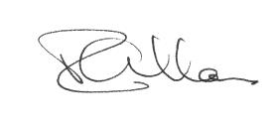
President, WL – N.GL VFD

Page 5
Notice of Annual General Meeting

Saturday, October 21st at 1:00 p.m. – Watch Lake Community Hall

Proposed Agenda:

President’s Introduction
Secretary’s Report
Treasurer’s Report
Fire Chief’s Report
Auxiliary Report
Tax / Fire Dues Issues
Election of Officers
New Business

Proxy No: ____
I, (print):________________________________________

of local area address: ______________________________,

as a fire dues paid member of the
Watch Lake – North Green Lake
Volunteer Fire Department (Society)
give my proxy to:
(print)____________________________________________

to vote on motions and resolutions raised
at the Annual General Meeting of the
Watch Lake – North Green Lake
Volunteer Fire Dept. (Society)
to be held on Saturday, October 21, 2017*
at the Watch Lake Community Hall.
Signed: _________________________________________

*valid only on date shown above

