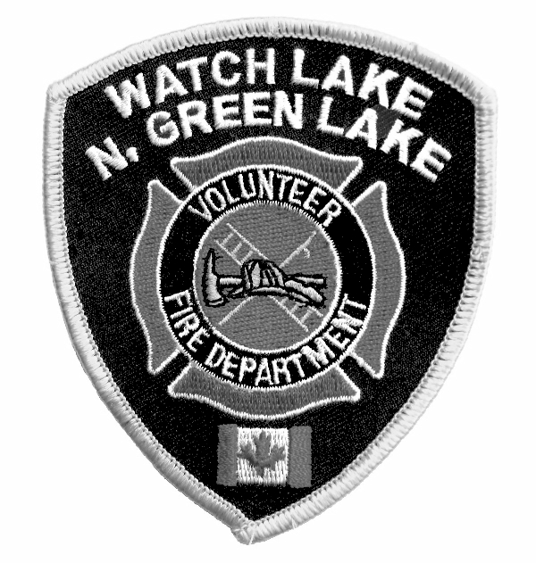WATCH LAKE – NORTH GREEN LAKE VOLUNTEER FIRE DEPARTMENT
R.R. #1, SITE 1, COMP. 4C, 70 MILE HOUSE, B.C. V0K 2K0
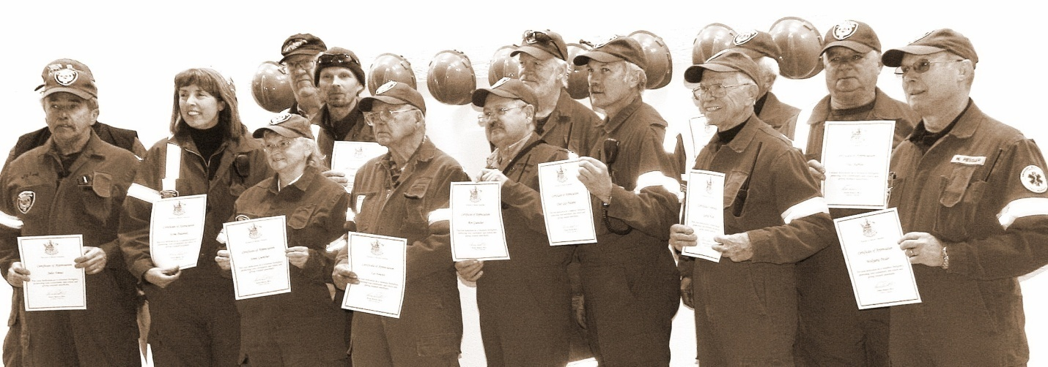
Certificates of Appreciation

NEWSLETTER – Annual General Meeting 2009

We are pleased to be able to send out a newsletter that contains mainly good news. Perhaps the best news is we have had no major fires in the last couple of months. Our crews did, however, respond to a head-on collision, a suspected heart attack, power lines down and a false alarm phoned in from South Green Lake in response to land clearing fires that could be seen across the water. In addition to this activity, the training sessions keep the whole crew active and ready to respond to emergency calls at any time.

The highlight of the fall season has to be the official opening and re-dedication of rebuilt Halls One and Two on October 10th. For those of you who were unable to attend the ceremonies, please feel free to drop by either hall when you have the time and see the great new training and garage areas. The day of the ceremonies was quite cool, but did not detract from the enthusiasm of the department members, auxiliary volunteers and visitors. The festivities were all a part of a BC 150 Volunteer Incentive Program Grant and we received a total of $3000 through this grant which will go toward the purchase of a front-mounted snow plow.

The day started at Hall #2 where the daughter, granddaughter and great grandchildren of the late Sonny Johnson, one of the founders of that hall, unveiled a plaque that will hang in the hall in his memory. The ceremony was concluded with a ribbon cutting to officially reopen the new addition to the hall.

At noon everyone moved to the somewhat warmer interior of Hall #1. This hall was originally named for Shorty Horn, the founder and first Fire Chief. Sadly, Shorty passed away this year and the hall has now been renamed the Shorty Horn Memorial Hall. His daughters were on hand to unveil a plaque in his memory that will hang in the finished assembly area. This ceremony was also concluded with a ribbon cutting by Shorty’s three daughters.

In his congratulatory remarks Cariboo Regional District Area ‘L’ Representative Bruce Rattray made mention how important it is to have total community involvement in a project such as this and how much it has helped the department achieve its goals on a very tight budget. He said that he believed the strong direction of the department has pulled together the many talented people in the area to create a very efficient and unified service to the community.

In her comments to the community Cariboo – Chilcotin MLA Donna Barnett congratulated the volunteers for their accomplishments and turned the audience’s attention to the spouses of the fire fighters. These people often work just as hard in the background and as a consequence are often unrecognized for their contributions. She concluded her remarks with a thank you to the volunteer fire fighters and first responders for their service to the community and gave each member a certificate of appreciation from the Province for their volunteer activities.

The celebration of the day’s events was capped-off with a dinner-dance at the Watch Lake Community Hall with a meal prepared by the Fire Department Auxiliary and dancing into the evening with music donated by the very popular local group, Whiskey River Duo.

Annual fire dues are now payable. Please remember our service fees for fire and first responder services to unpaid properties. We have had two 911 calls over this past year to residences where the dues were not paid and invoices have been sent to the owners. If we get no response, the membership has directed us to turn these matters over to a collection agency.

Chief Poliseno has been looking for more volunteer fire fighters from the Hall One (Watch Lake) area. Compared to other communities we have a good sized department, but a better balance of volunteers between the two halls would reduce our response time in the Hall One area. If you can find the time, come out and join your neighbours in this vital community service.

Please have a safe holiday season. Many fires occur during Christmas and throughout the winter months when we have trees, candles and other decorations in our houses. Chimney fires happen often during the coldest of weather and usually with devastating effects.

Yours truly,
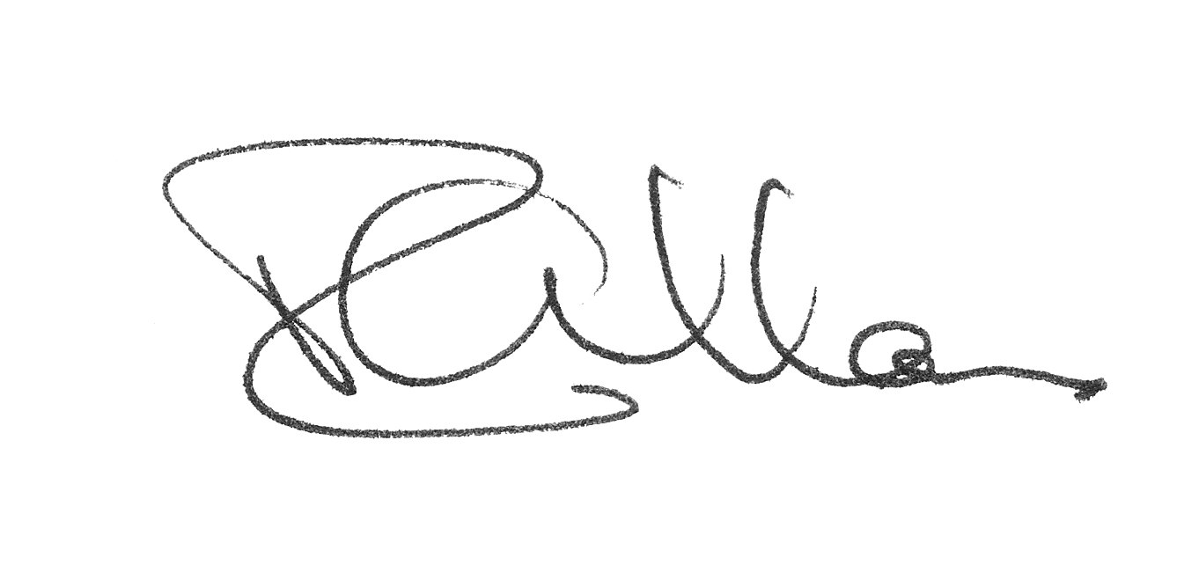
Roy Allan
President, WL-N.GL VFD

The Annual General Meeting will be held on
Sunday, February 7th at 1:00 p.m. at the Watch Lake Community Hall.
Nominations are open for election to the Board and we welcome your participation.

Agenda:

President’s Introduction
Minutes of Last Meeting
Secretary’s Report
Treasurer’s Report
Chief’s Report
Old Business
Legal Issues
New Business
Election of Board Members

