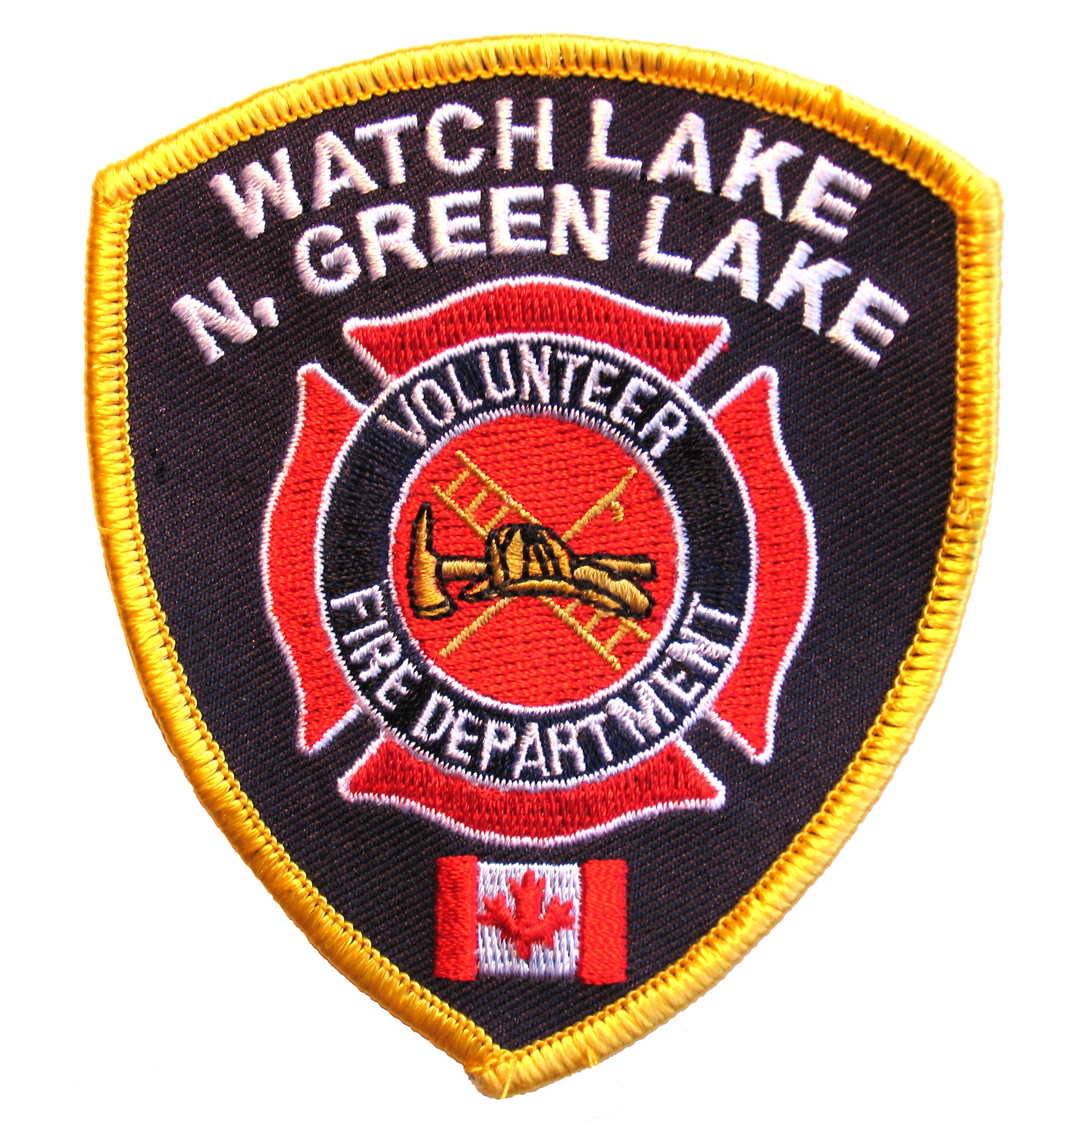WATCH LAKE – NORTH GREEN LAKE VOLUNTEER FIRE DEPARTMENT
R.R. #1 SITE 10 COMP. C-0, 70 MILE HOUSE, B.C. V0K 2K0

NEWSLETTER – JANUARY 2008

FIRE FIGHTERS:

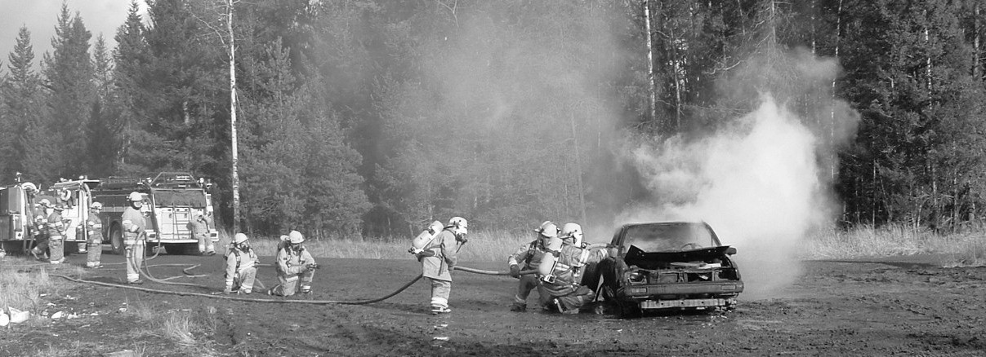

In spite of operating on a shoestring budget, your fire department has continued to provide the best possible service to the community. We are continuing to work around the massive debt left us by past legal difficulties and, through the assistance of a gaming grant, we have managed to equip and begin the training of a force of thirty three fire fighters. Poor payment of annual fire dues made the purchase of a much-needed, newer truck for Hall #1 totally out of the question for the past year, but we hope for better support in 2008. It is the protection of your property, your family and you that is at risk.

Twenty-two of our members are enrolled in the Fire Fighter 1 program given by College of the Rockies and on-going, weekly practices include training in elements of that curriculum given by experienced members of the department. Several members from Hall #1 are attending training sessions with the 100 Mile House Fire Department and sharing the skills learned there with the other members. Monthly combined practice of the fire fighters from both Halls 1 and 2 help the crews become familiar with all of the department’s equipment. Other training, given by a visiting instructor from the Justice Institute, familiarized all members of the department with the use of newly purchased positive pressure fans.

The results of the year’s training were highlighted in November with a practice burn at the Watch Lake Dump. Under the guidance of our newly appointed Acting Fire Chief, Guy Poliseno, a combined crew from both Halls fought a simulated vehicle fire and gained some valuable, first-hand experience fighting the fire and using their SCBA units.

In order to provide radio communication in several “dead” areas, we have upgraded the radio equipment on the Mt. Jim tower. This improvement was necessary to improve communication between crews and with the radio dispatch in Prince George. With the acquisition of new the new radios provided for in this year’s gaming grant our fire crews will work more safely and efficiently at a fire scene. We had hoped for some financial assistance from the CRD with the upgrade but, since we are not a member of the CRD Protective Services, this will not be forthcoming.

Page 2

FIRST RESPONDERS:

During the summer several fire fighters along with a few members of the community took a combined CPR / AED course in preparation for the First Responder 2 course given in September. Upon completion of this training we were able to re-establish the First Responder Service and with trained personnel from Watch Lake and Green Lake emergency medical service is now available to the whole community. All of the First Responders will be completing the Level 3 course throughout January. Negotiations are under way to obtain a grant for a second AED unit so that a defibrillator can be dispatched more quickly to any area of the community.

FUND RAISING:

As a response to the poor payment of annual dues some of the members suggested setting up a fund raising committee to attempt to raise funds for the purchase of the new vehicle. Their first event, the play night Aunt Martha’s Funeral, raised just over $200 and a further $100 was collected by passing a helmet. On the 9th of February a Mardi Gras / Casino Night will be held at the Watch Lake Hall and early ticket sales indicate that this should be a successful venture.
In order to encourage payment of the 2008 fire dues (which are now due) we will be acknowledging those property owners who have paid with a sticker to affix to their fire number (address plaque). These stickers will be distributed by the fire fighters this Spring. For this year the background colour will be red and in future years the background colour will be changed. | 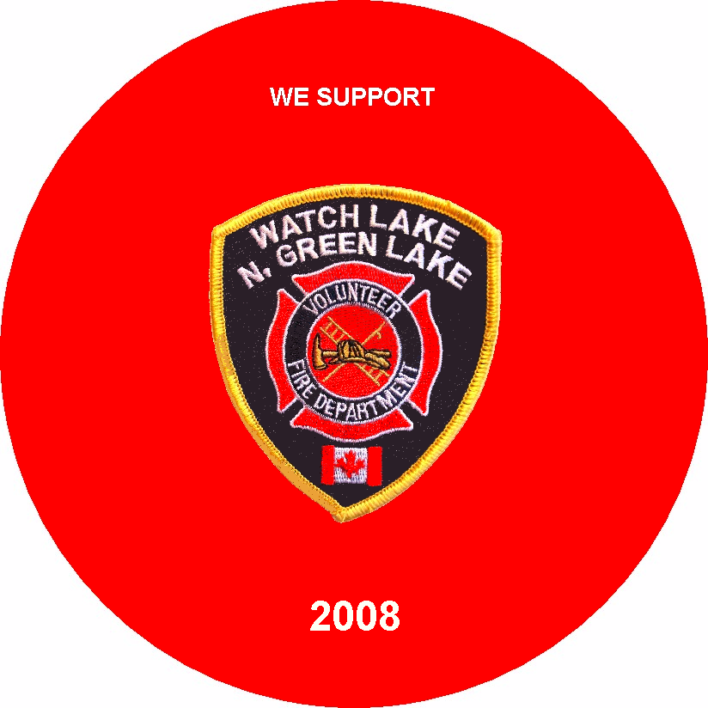
We wish you all a healthy and peaceful new year.

Roy Allan
President, WL - NGL VFD

THE CHIEF’S CORNER:

In 2007 the Fire Department saw several changes and by the end of the year numerous new members joined both Halls. In November two members obtained their Live Fire I certification and three members became RIT (Rapid Intervention Team) qualified. Throughout the coming year we will be participating in joint exercises with other communities in programs designed to prevent a repeat of the 2003 fire disasters.

Many people have fire extinguishers in their homes but yet have never used one. For members who have paid their dues the fire department will demonstrate the proper use of a fire extinguisher and fire fighters will discharge one at no cost.

A short safety note – during long power outages like the one we recently had, please don’t use your telephone for anything except emergencies. Extra use depletes the backup batteries and the whole system could go down.

We have a beautiful community and more people are finding the area a peaceful place to reside. As your new fire chief I cannot guarantee continued safety if we do not have your support and if the members of this community do not pay or simply ignore paying their fire dues. Look at your surroundings and ask yourself, is it worth it?

Guy Poliseno
Acting Fire Chief, WL - NGL VFD

