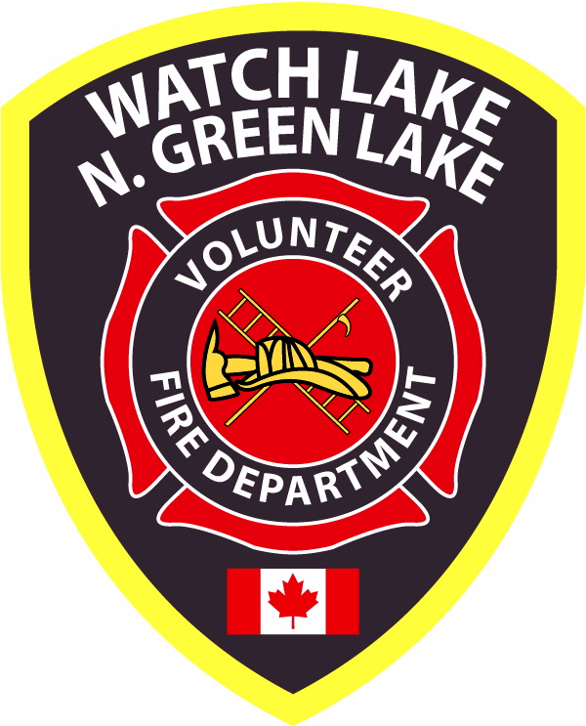 WATCH LAKE – NORTH GREEN LAKE VOLUNTEER FIRE DEPARTMENT
R.R. #1, SITE 10 COMP. C-0, 70 MILE HOUSE, B.C. V0K 2K0

NEWSLETTER – December 2008

Annual General Meeting - Saturday, February 21, 2009 - 1:00 p.m.
at the Watch Lake Hall

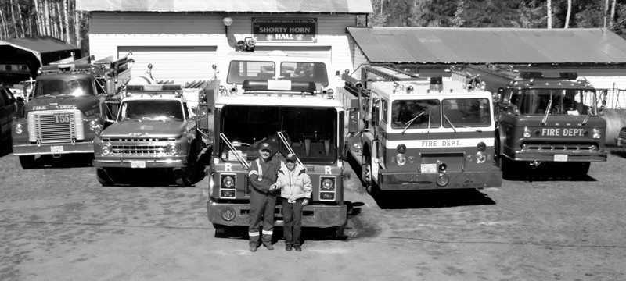
The new truck and fleet with Fire Chief, Guy Poliseno and First Fire Chief, Shorty Horn

Your Fire Department has experienced an exceptionally successful year. With the assistance of many so many members of the community we have continued to develop the level of emergency services appropriate for a mixed use district such as ours. As we have said in previous newsletters the men and women on your department today are continuing a proud tradition of fire and first responder service for which this area has long been known. Many of the founding members, volunteers and directors are still active in our community and we hope they too share in the pride we have in the service we are able to provide today.

Under the skillful leadership of the Fire Chief, Guy Poliseno, our fire fighters are undergoing continuous training at the weekly practice sessions and many have taken part in additional training with the 100 Mile Fire Department. Members from the 70 Mile House Fire Department have also attended many of our practices. Our First Responders, under the enthusiastic leadership of KD Moro, meet on a second night each week to practice emergency patient care. Throughout the past year there have been several call-outs for the Fire Department and they have had a couple of good practice fires, but the First Responders have seen most of the action and they must be praised for their rapid response and professionalism.

We have 27 active members in our Department, but with some away at work during the day and others heading south for the winter, we can always use more volunteers. If you are interested in joining and committing one morning per week of your time for this service to the community, please contact a neighbouring Fire Fighter or Chief Poliseno.

During this past year you have no doubt heard that we had the good fortune to receive from the City of Coquitlam the donation of a new addition to our fleet of vehicles. This truck, a 1986 Mack pumper has turned out to be almost as good as new and will delay the need for a newer truck for a couple of years. With new trucks costing upwards of $200,000 this will give us time to work on creative fund raising to at least cover the cost of something well within the twenty years of age limit.

Unfortunately, our newly donated truck and other, future vehicles are too big for the size of the present fire halls. This encouraged the voting membership to embark upon a rebuilding project for both the Shorty Horn and Sonny Johnson Halls. These additions will give the department room for larger trucks, and interior training areas for winter sessions. The two first responder vehicles will also be moved in, out of the cold. A number of our property owners signed-up to pay their dues in advance for the next five years to give us the cash basis for a Major Capital Grant application. This, combined with cash donations and a commitment of time from many members will hopefully see our application granted and allow us to start the project in the spring of 2009.
In order to encourage payment of the 2009 fire dues (which are due on January 1st) we will again be acknowledging those property owners who have paid with a sticker to affix to their fire number (address plaque). The distribution of the stickers for 2008 did not work out as planned and many property owners did not get one. For the current fiscal year we will deliver the stickers upon request or have them available for pick up. For 2009 the background colour will be yellow and in future years the background colour will be changed. | 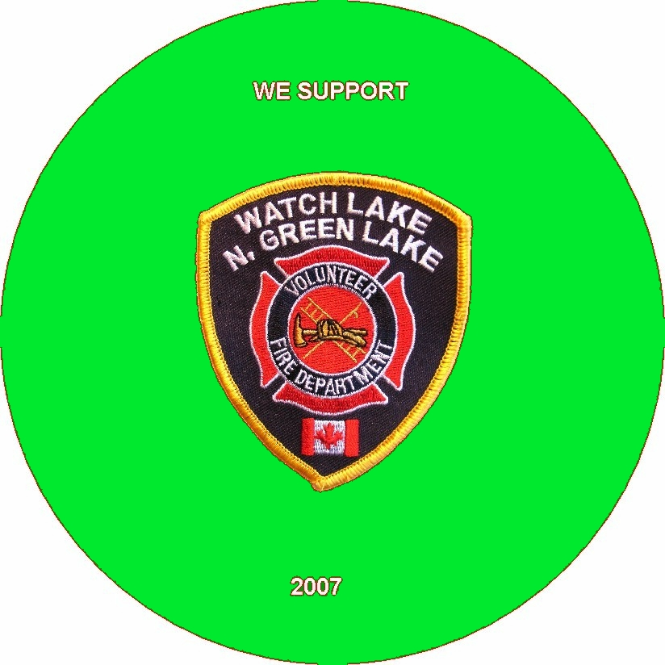
The 2008 fiscal year saw the best payment of fire dues by property owners in the history of the Department and the Chief, Fire Fighters and First Responders thank you for your support. There are still about 25% of our residents who have not paid their dues and in keeping with the procedures in other communities we will be charging a service fee for fire response or emergency service to unpaid properties. There has been an unwritten fee for service for many years, but to make this enforceable the following service fees were voted into our bylaws at the Summer General Meeting and comes into effect as of January 1, 2009. This bylaw, Article #21, states:

Services for property owners who have not paid their current fire dues.

a. There shall be a service fee of $1000.00 per hour for fire call-outs, (minimum of 2 hours.).
b. There shall be a service fee of $500.00 for First Responder call-outs.
c. Members of the Society of the present year will not be deemed delinquent until
March1st of the following year. (e.g. 2008 members are delinquent as of Mach1, 2009)
d. The board will have the right to either use the Small Debts Court and / or a Collection
Agency to recover service fee stated in (a.) and (b.) above.

At the February 21st, 2009 AGM elections will be held for a new Board of Directors. We need more volunteers to fill the slate of twelve director positions available. If you can find the time to serve your community in this way, please contact the Nominating Committee through Kathy Wilson at 250-456-6028. You do not need to be a full-time resident to be on the board.

We wish to take this opportunity to once again thank everyone in the Watch Lake - North Green Lake community for their help and encouragement over the past year and to wish you all a safe, healthy and peaceful holiday season and new year.

Roy Allan
President, WL-N.GL VFD

The Fire Chief’s Corner

In my last letter I mentioned that with the coming of the summer the possibility of forest fires was real. In 2008 we responded to two forest fires, one on Green Lake was cause by a lighting strike and being inaccessible by vehicle, the forestry helicopter had to be called.

The second fire was cause by a negligent person in a densely wooded area at the base of Box Hill accessible by foot only; it was extinguished by a joint effort from your Fire Department and Forestry personnel.

Since the start of the year, 13 members of the Fire Department have started the Basic Fire Fighting Certification Program. They will be writing their final exam in January and will be presented at the AGM their certificate of accomplishment from The Fire & Safety Division of the Justice Institute of British Columbia.

In Feb. 2009 the First Responders will by attending the Automated External Defibrillator & Spinal Course and some members will also attend the First Responder Instructor’s course.

At the beginning of November, the 70 Mile House Fire Department answered a call to a chimney fire in their local area. They discovered that there were a couple of inches of soot in the pipes. This is a reminder to everyone to check and clean their chimney when required. Please don’t wait for a fire to ignite.

As a community service the Fire Department will conduct pile burning on private land with no direct cost to members of the society, but a donation to the Fire Department is encouraged to pay for the cost of fuel. It has been notice that some piles were dangerously stacked alongside dead trees and power lines. This is a practice that should stop, especially when there is a large open area available.

At the completion of the AGM, your Fire Department will once again have a training session on Fire Extinguishers. This invitation is for everyone.

Guy Poliseno
Fire Chief

Watch Lake - North Green Lake Volunteer Fire Department Auxiliary Update

Auxiliary Society AGM, Tuesday April 7, 2009 @ Watch Lake Community Hall: 9:30 a.m. Coffee, 10:00 sharp meeting starts.

Agenda:
Planning of 2009 activities
- Garage Sale May 16, 2009
- Dinner & Auction June 20, 2009
- Fire Fighter’s Ball – October 10, 2009
- Meet & Greet picnic
- Important monetary decisions
- Election of officers

New members (men and women) very welcome. There is now a $2.00 annual membership fee.

------ // ------

